**V6 incident manager module**

New Incident Form Page

URL: https://t100riskmanager1.com/v6_3/AccidentManagerDashboard/CreateNewForm

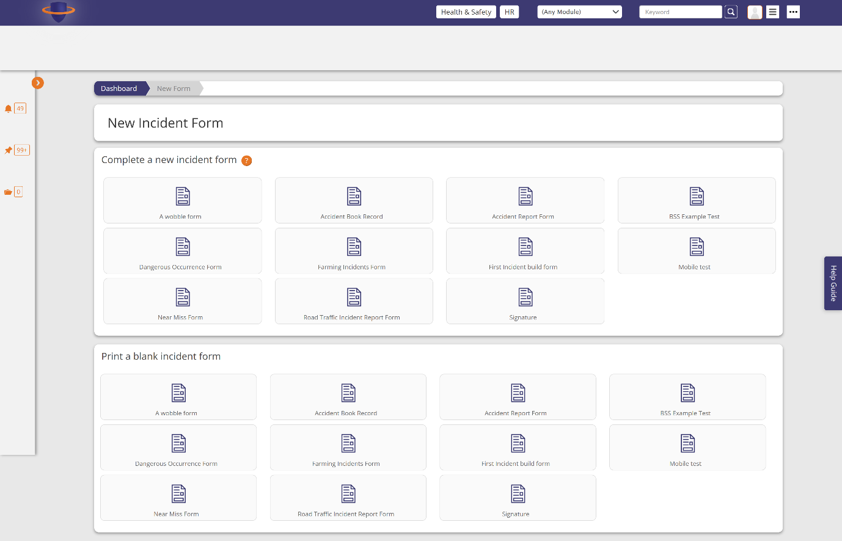

A wobble form modal

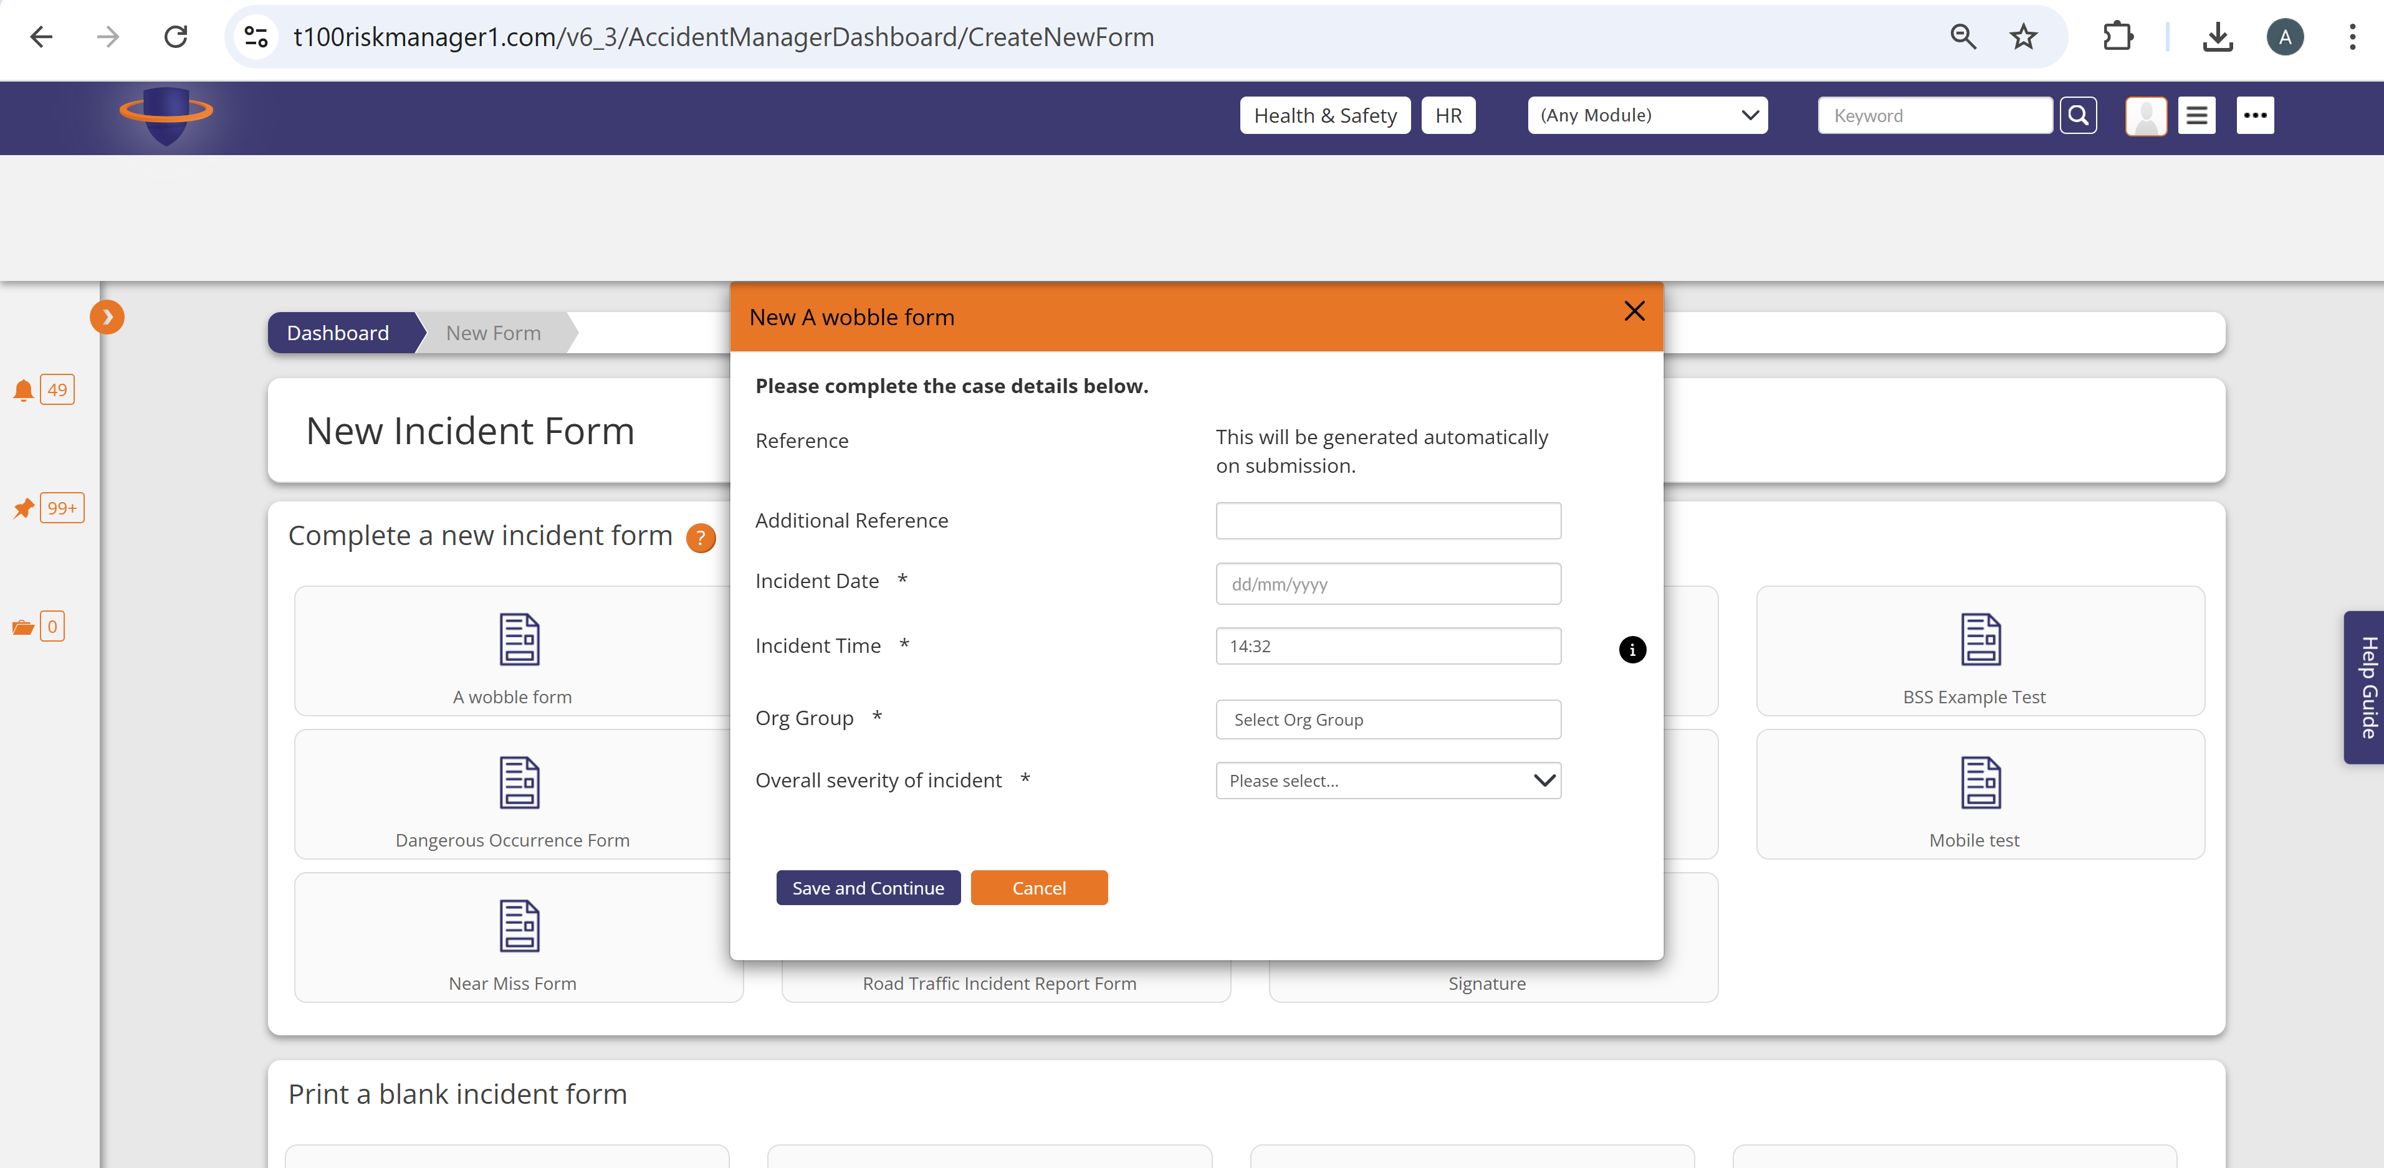

A wobble form – org group modal

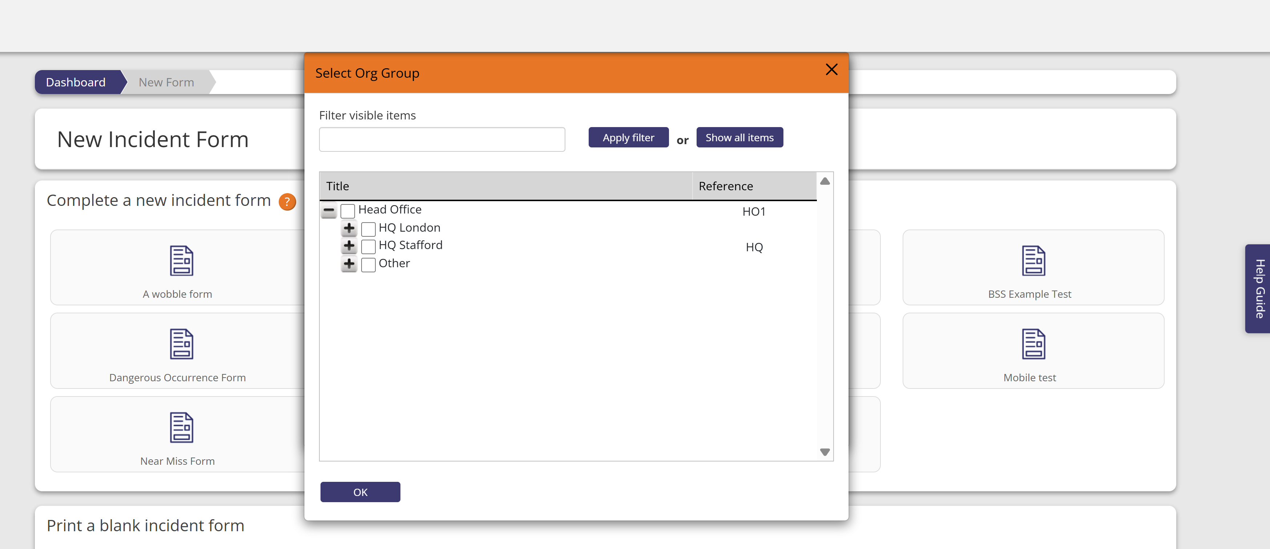

Wobble form - <https://t100riskmanager1.com/v6_3/AccidentForm/Edit?accidentFormID=127845>

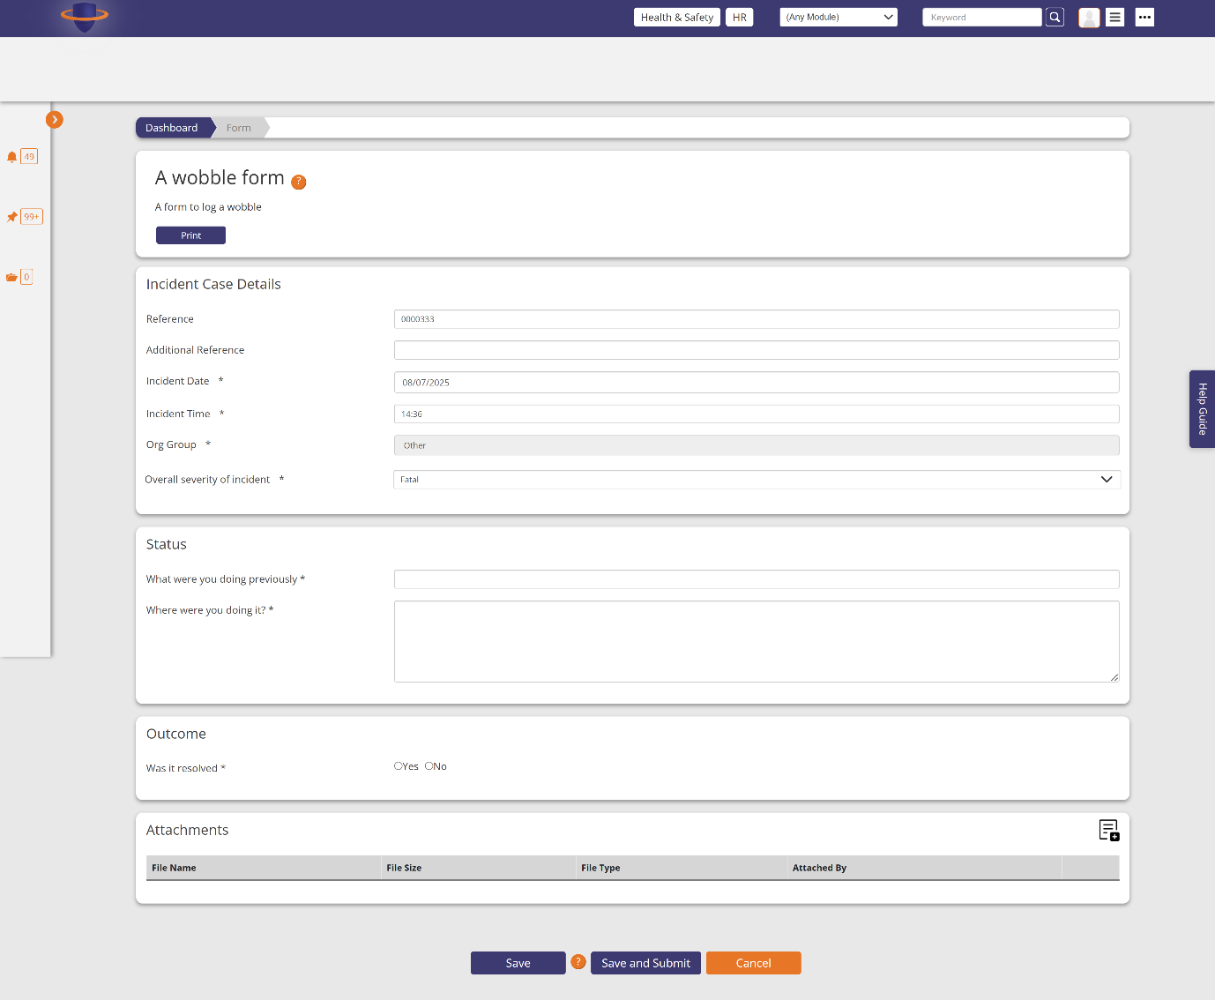

Case details after you press save and submit for the wobble form

<https://t100riskmanager1.com/v6_3/AccidentCase/CaseDetails?accidentCaseID=75680>

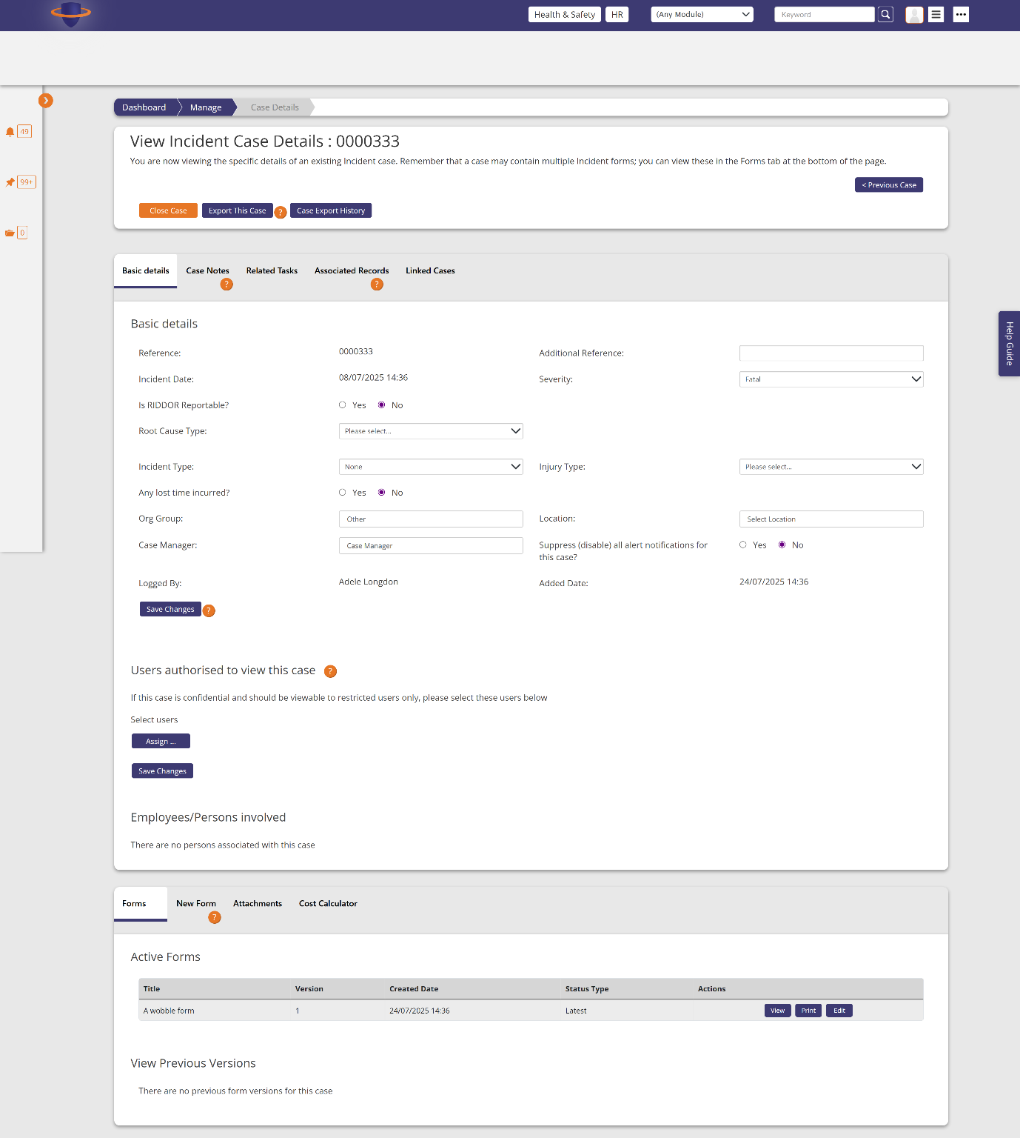

Accident Book Record form

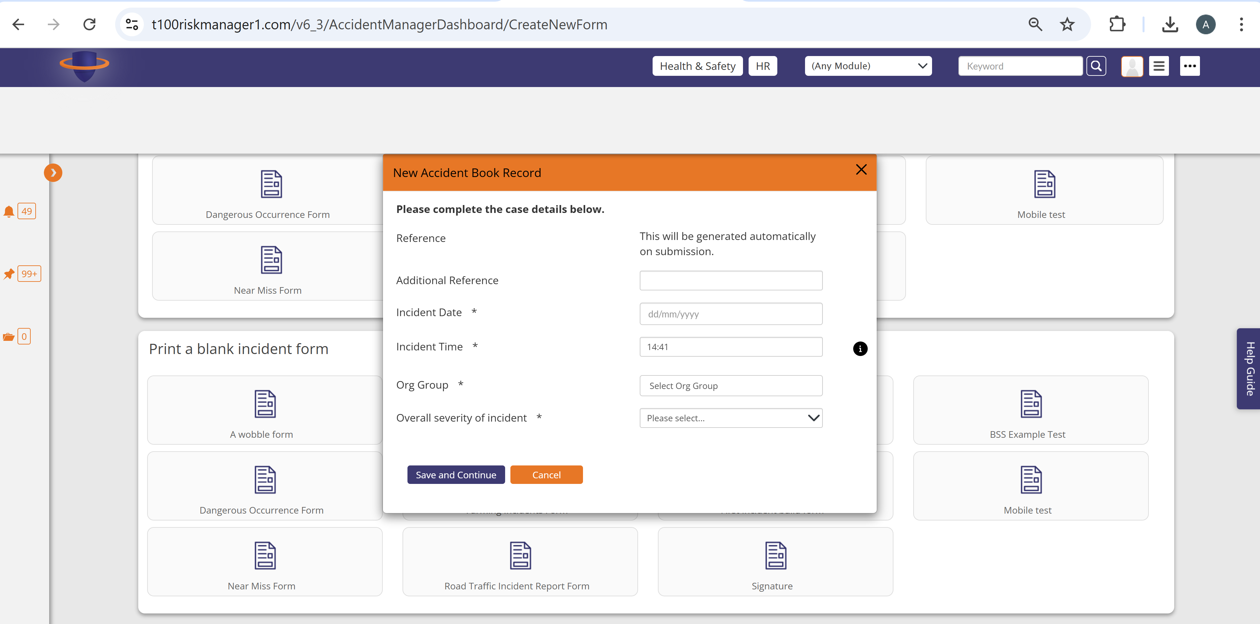

Accident book record – full form after pressed save and continue in the modal

https://t100riskmanager1.com/v6_3/AccidentForm/Edit?accidentFormID=127846

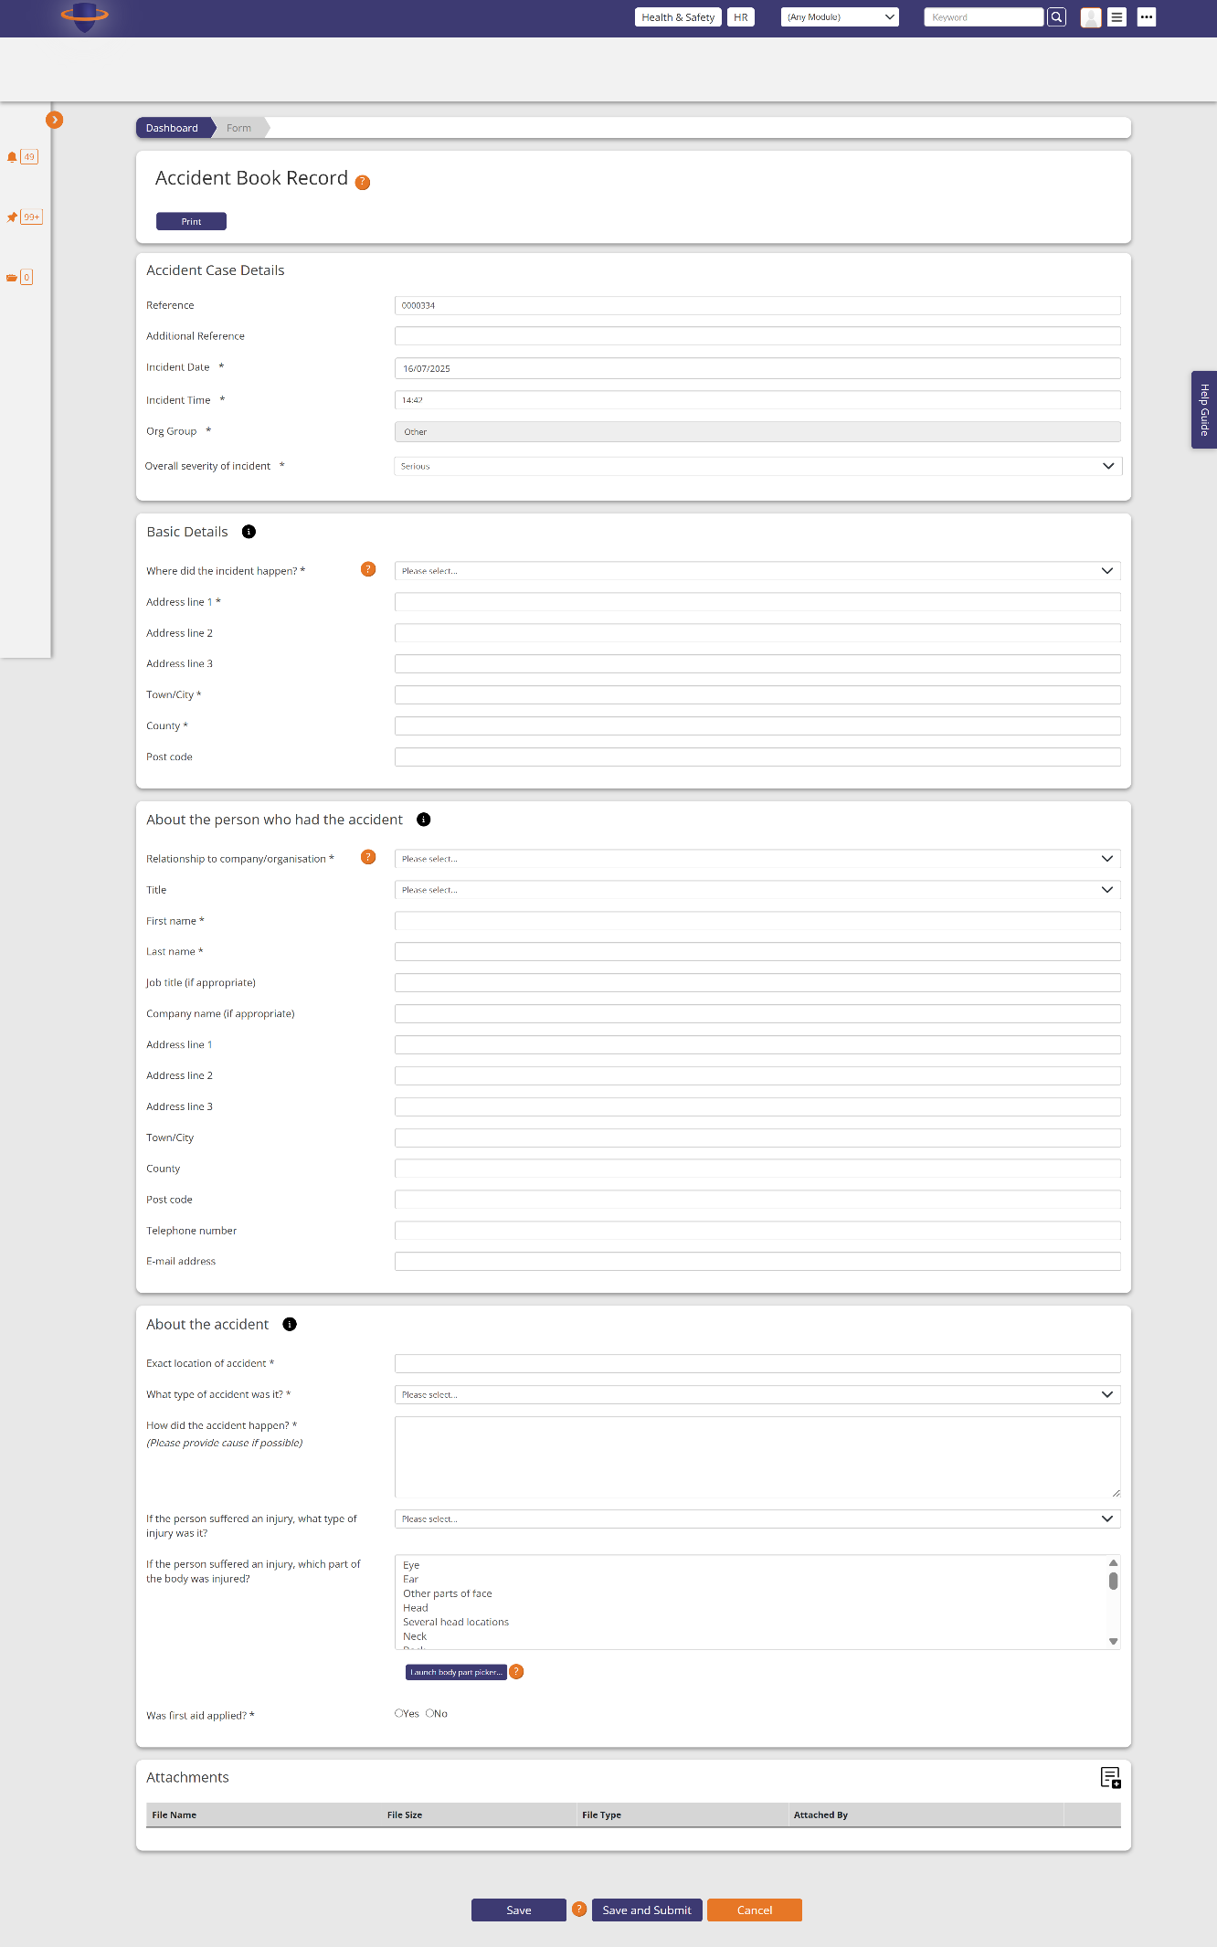

The body part picker from the Accident record form

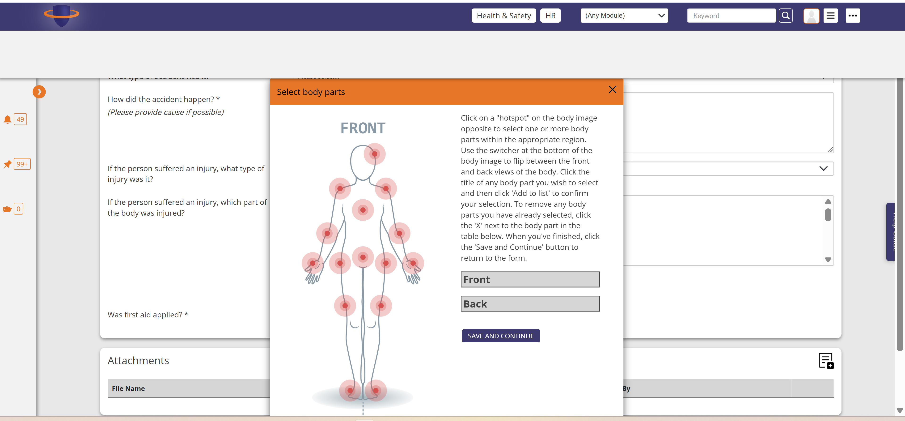

Accident Report Form

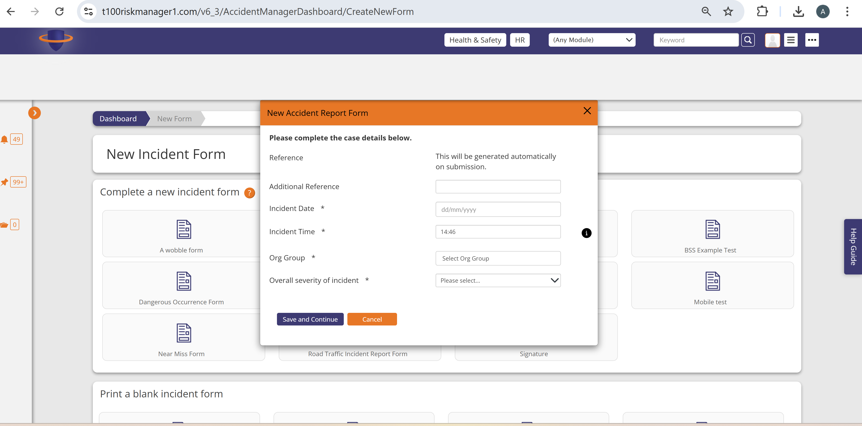

Accident Report Form – full form after the save and continue

https://t100riskmanager1.com/v6_3/AccidentForm/Edit?accidentFormID=127847

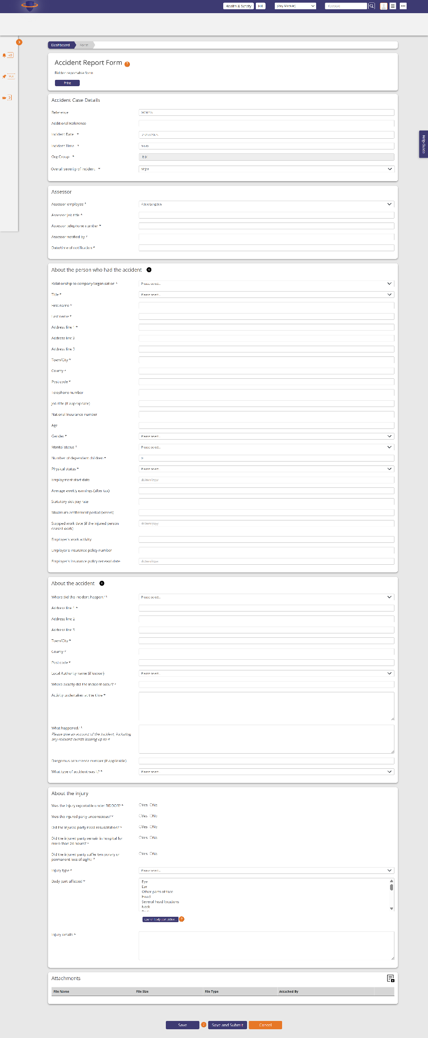

 Dangerous Occurrence Form

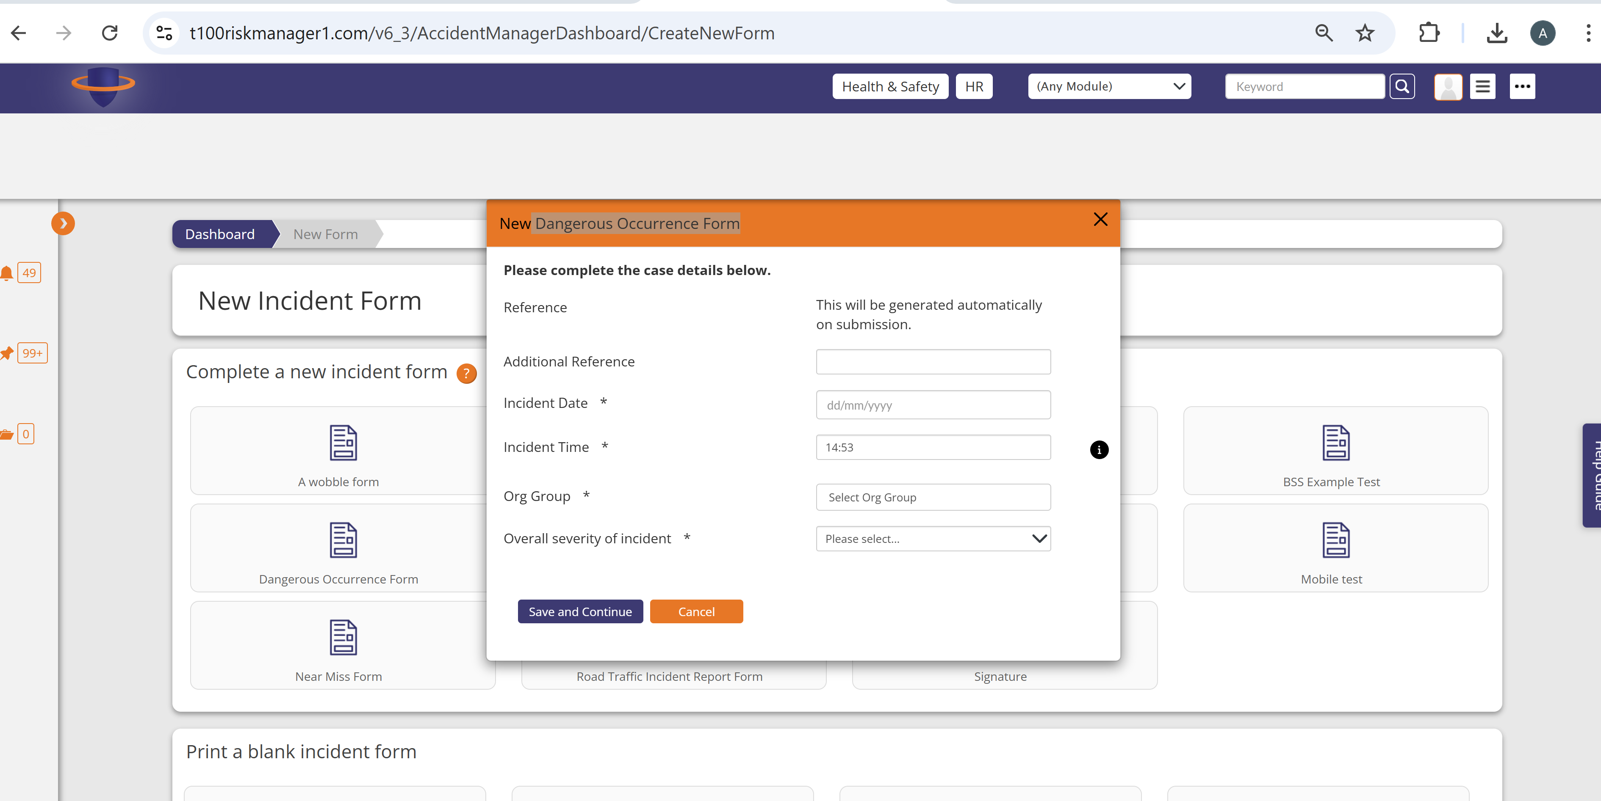

 Dangerous Occurrence Form – full form after save and continue

https://t100riskmanager1.com/v6_3/AccidentForm/Edit?accidentFormID=127848

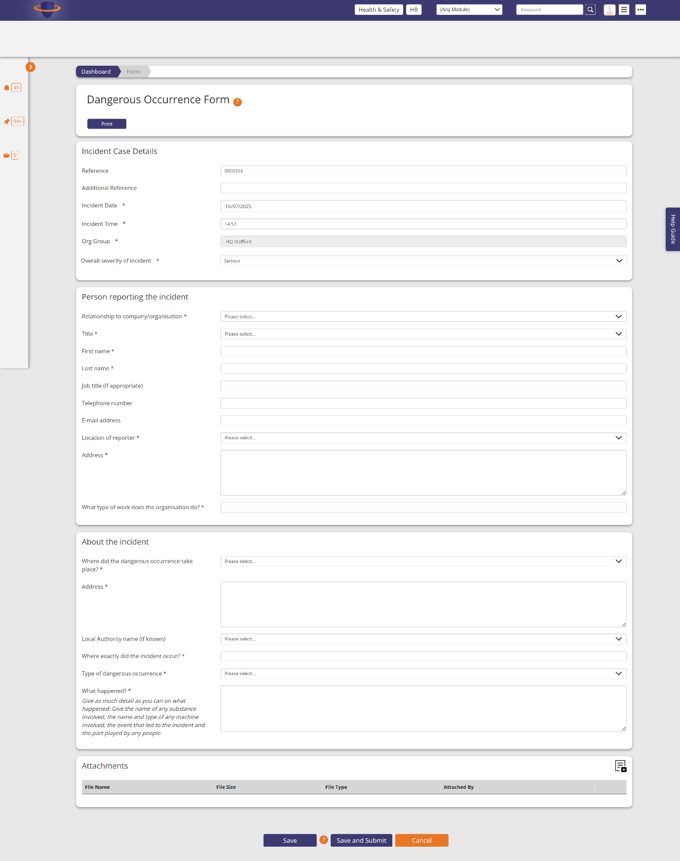

New Farming Incidents Form

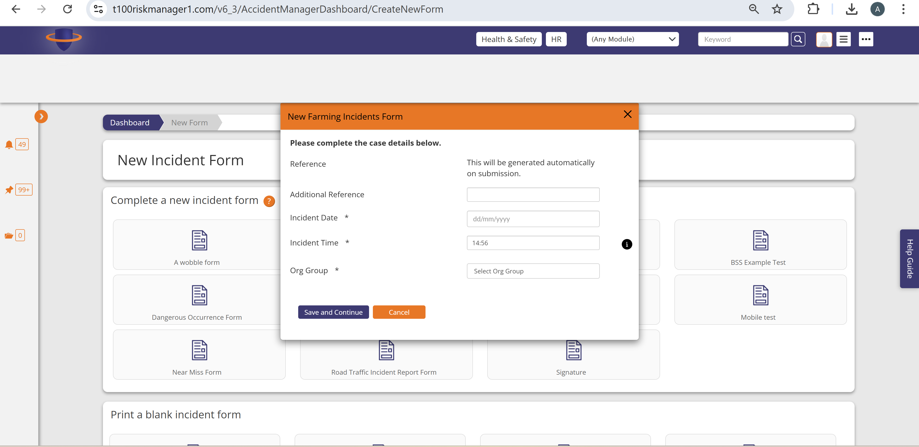

Farming Incidents Form – full form after save and continue

<https://t100riskmanager1.com/v6_3/AccidentForm/Edit?accidentFormID=127850>

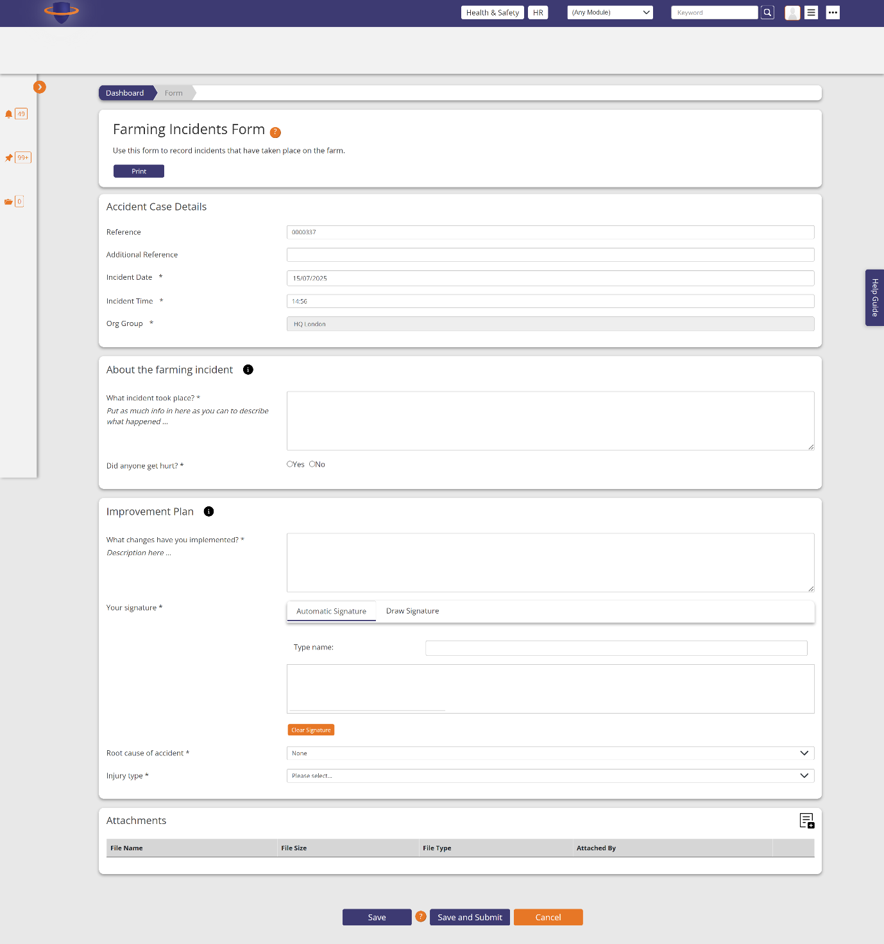

New Near Miss Form

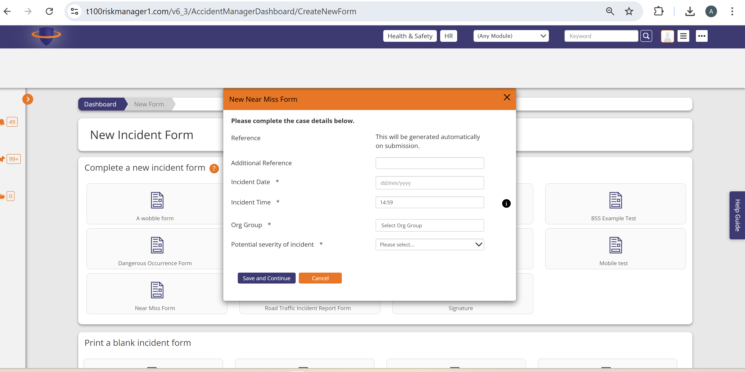

Near miss full form after save and continue

<https://t100riskmanager1.com/v6_3/AccidentForm/Edit?accidentFormID=127851>

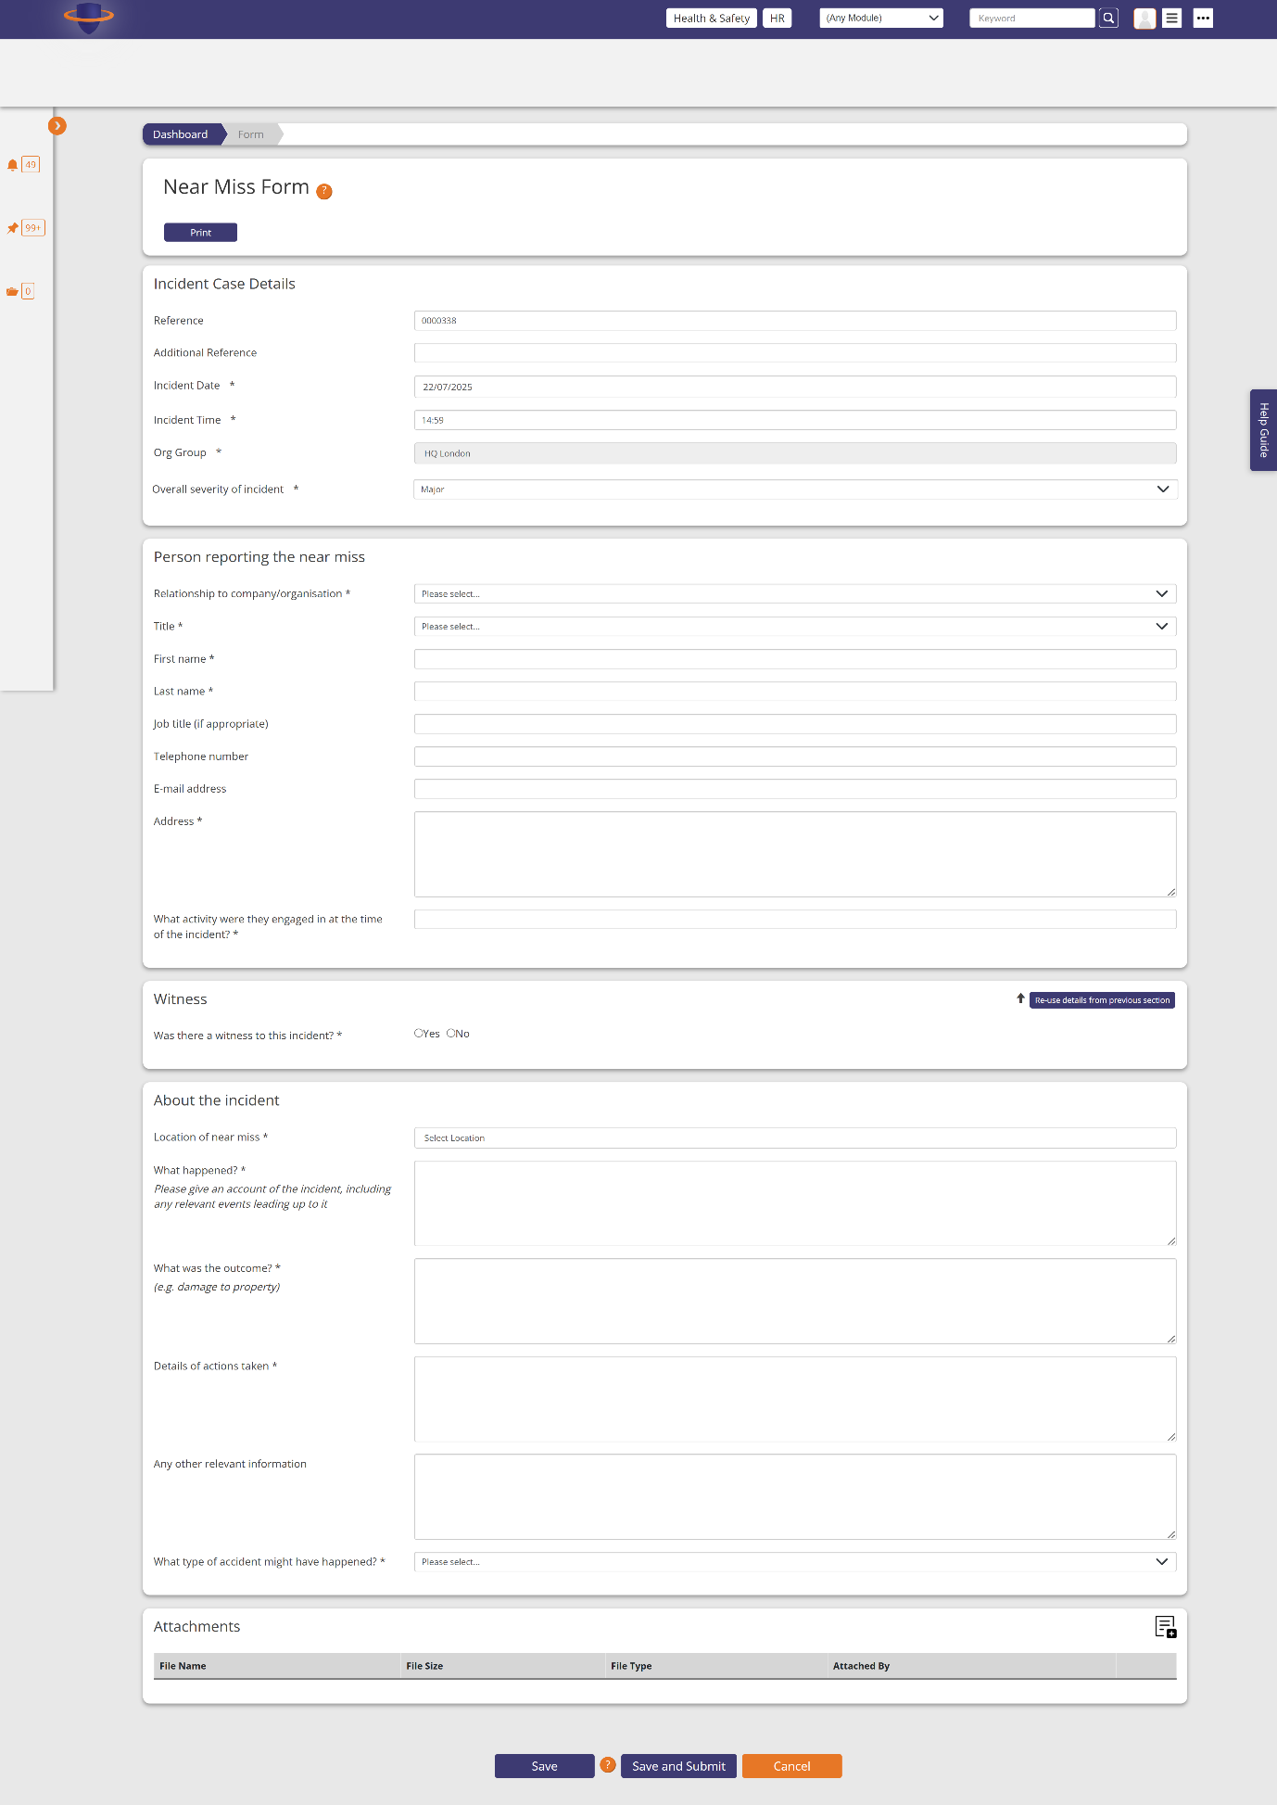

New Road Traffic Incident Report Form

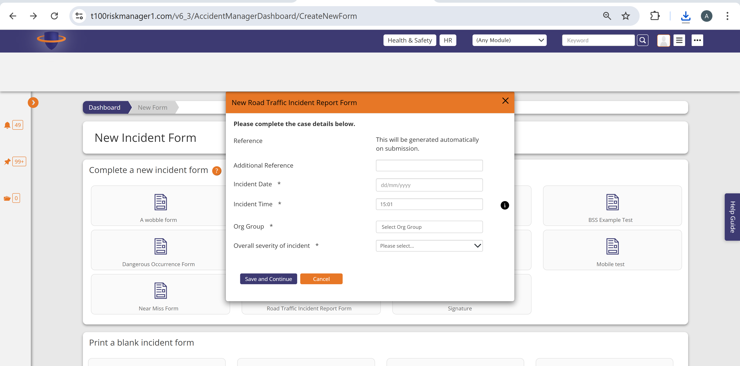

Road Traffic Incident Report Full Form after save and continue

<https://t100riskmanager1.com/v6_3/AccidentForm/Edit?accidentFormID=127852>

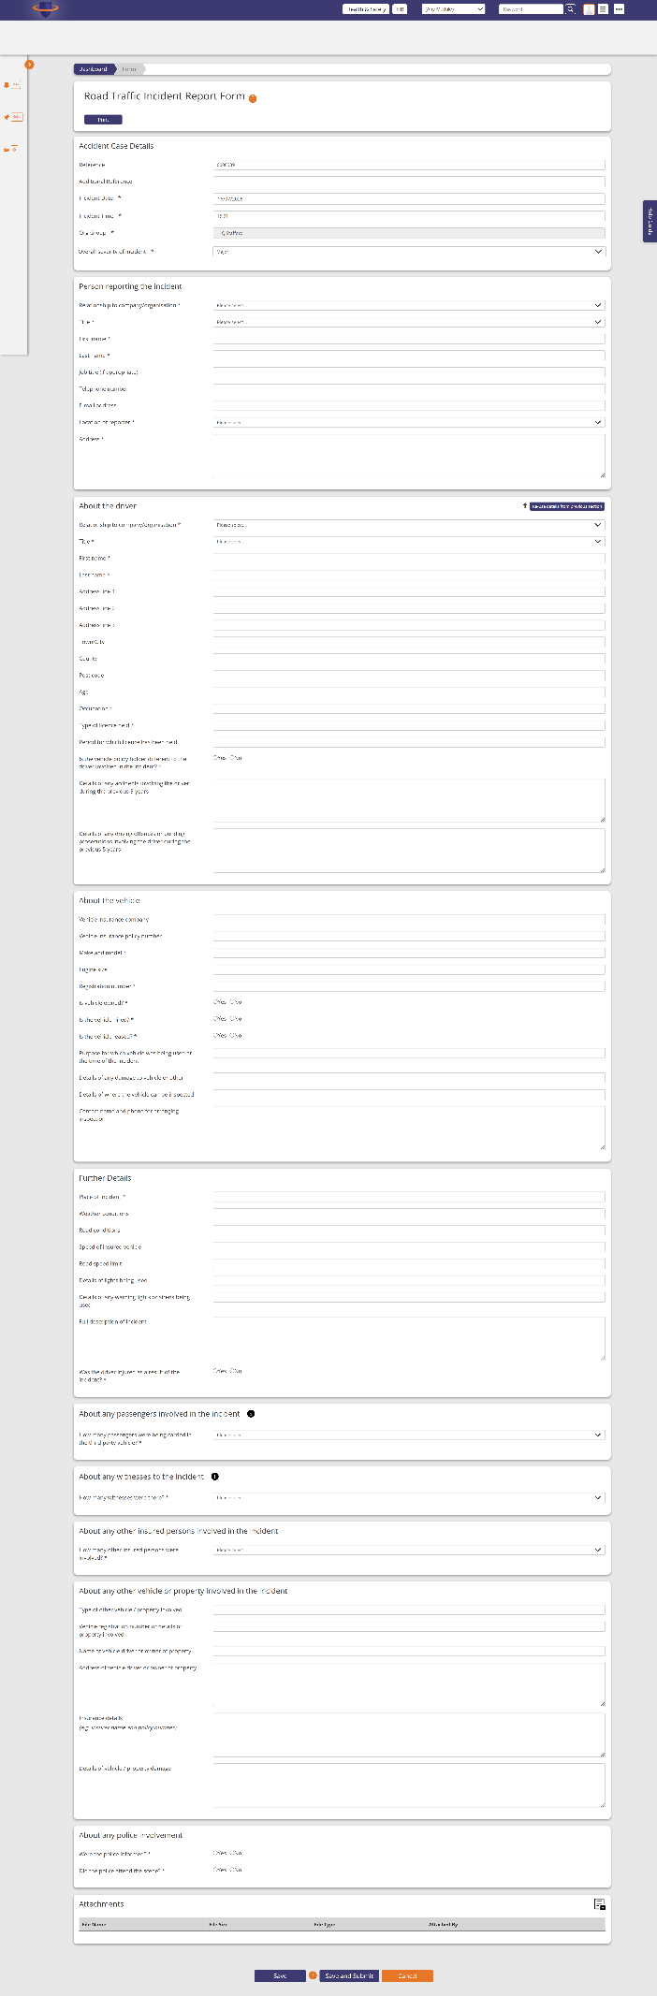

Select a header for when you click print blank form

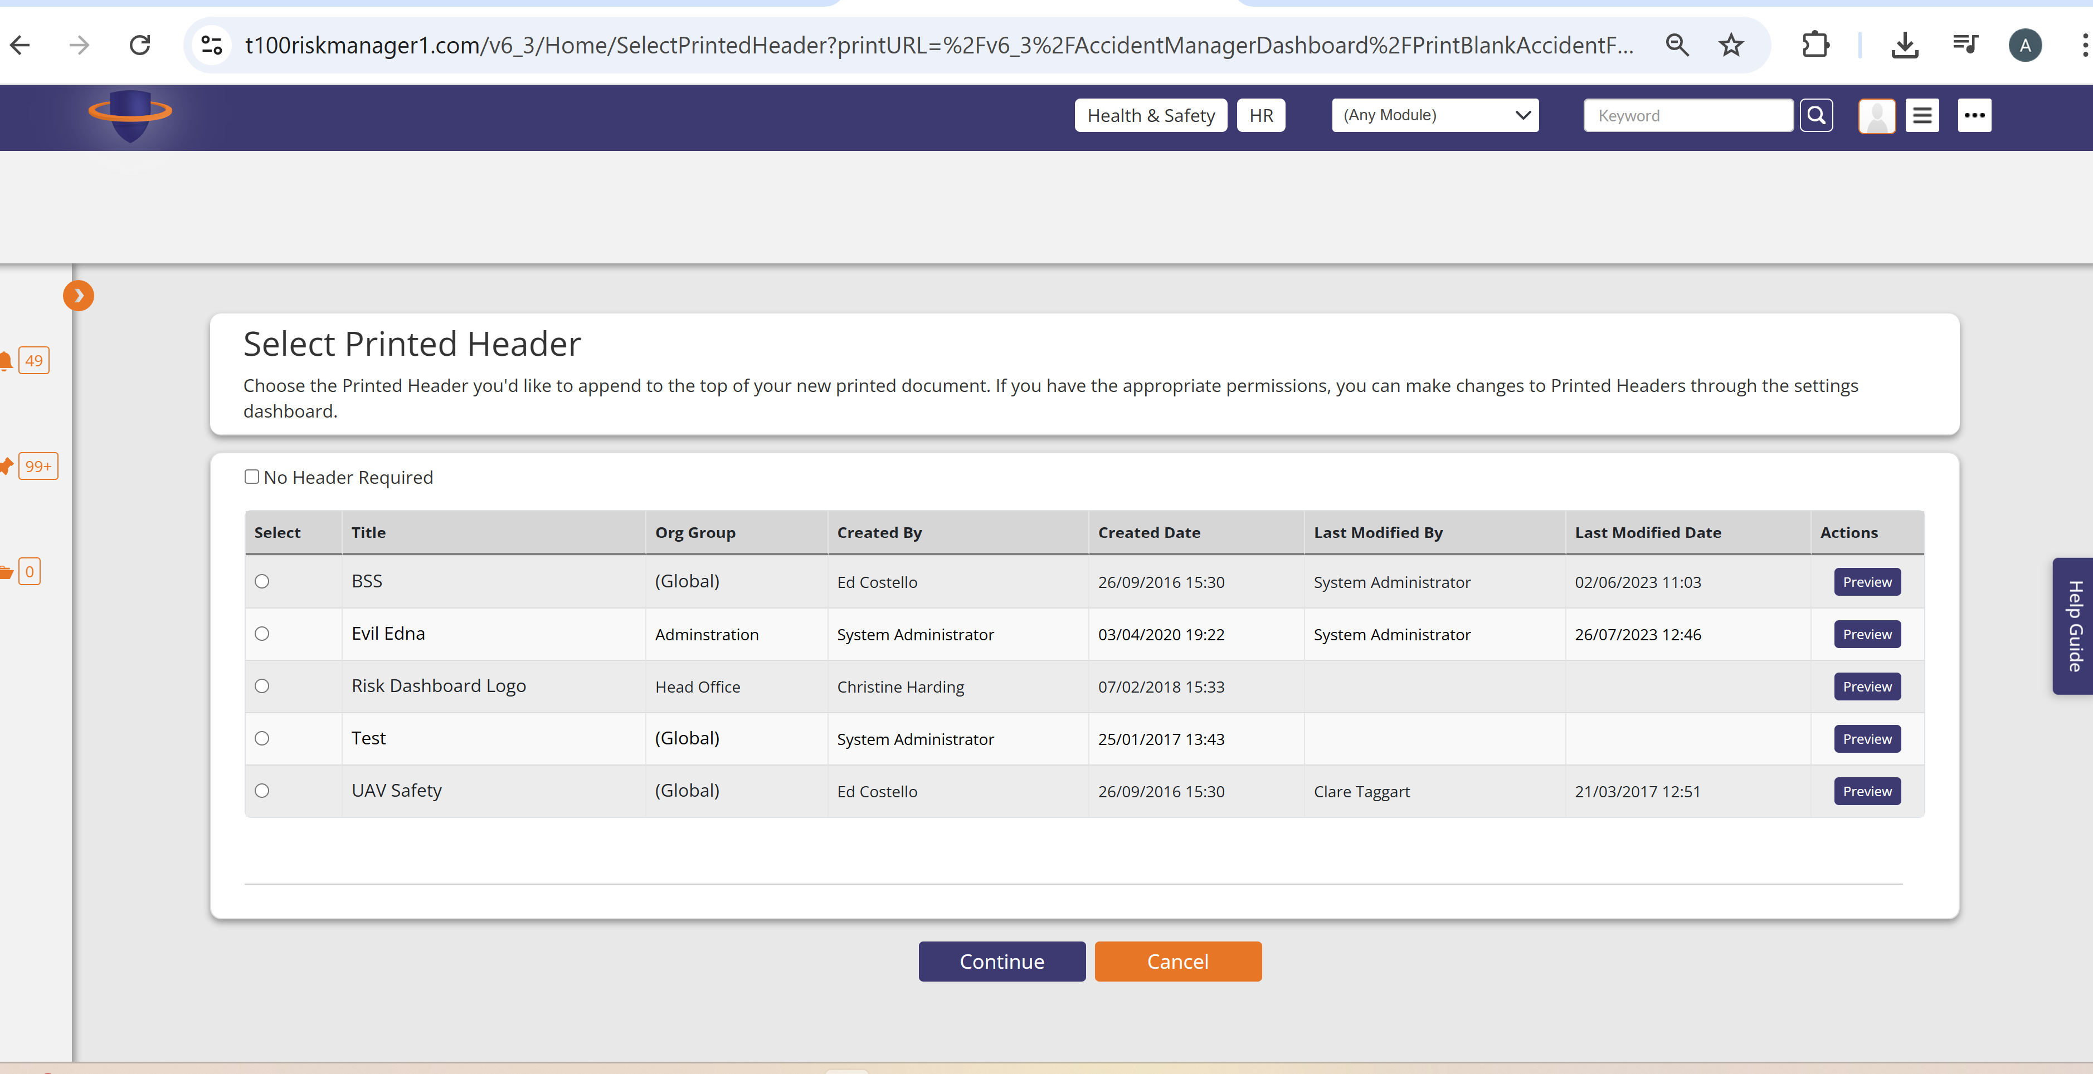

When click continue it creates a pdf version of forms above

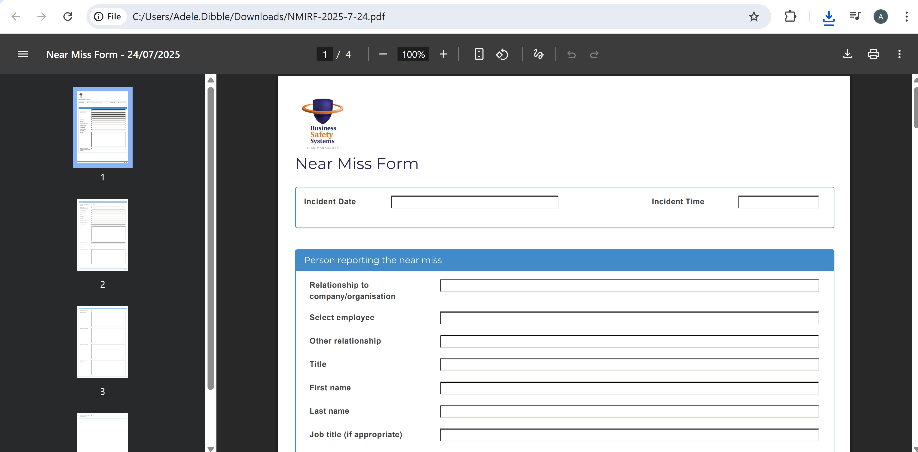

Incomplete Incident Forms

<https://t100riskmanager1.com/v6_3/AccidentManagerDashboard/IncompleteFormsList>

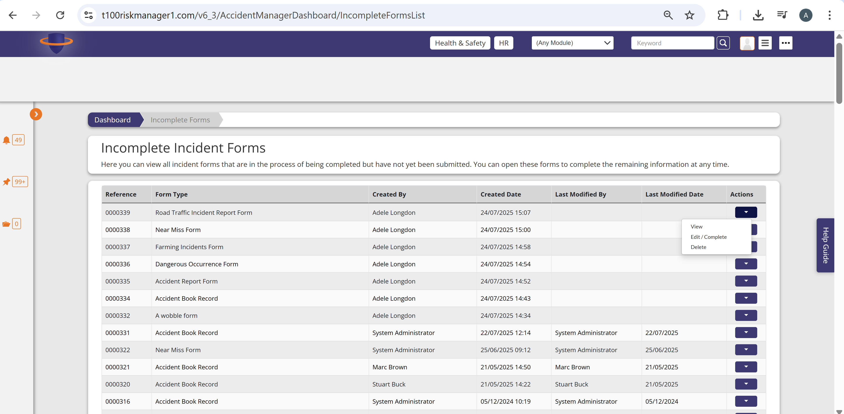

View an incomplete form - <https://t100riskmanager1.com/v6_3/AccidentForm/View?accidentFormID=127852>

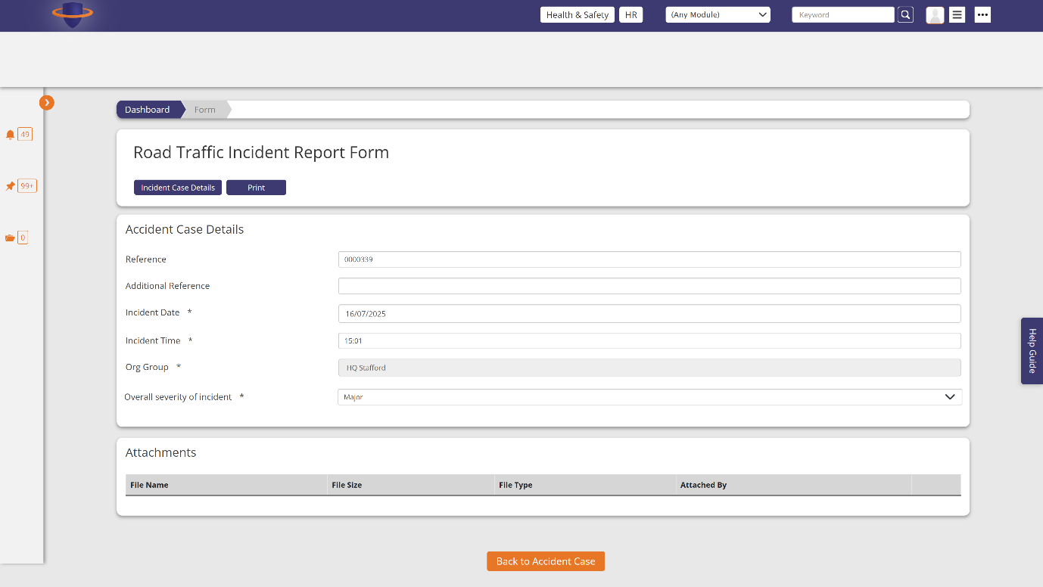

Edit an incomplete form (different form from above to show a different type) - <https://t100riskmanager1.com/v6_3/AccidentForm/Edit?accidentFormID=127852>

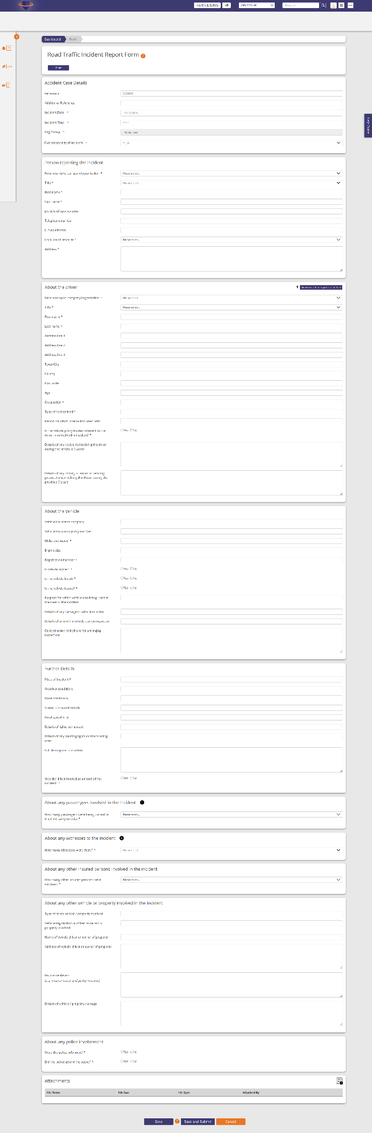

Are you sure modal when go to delete an incomplete form

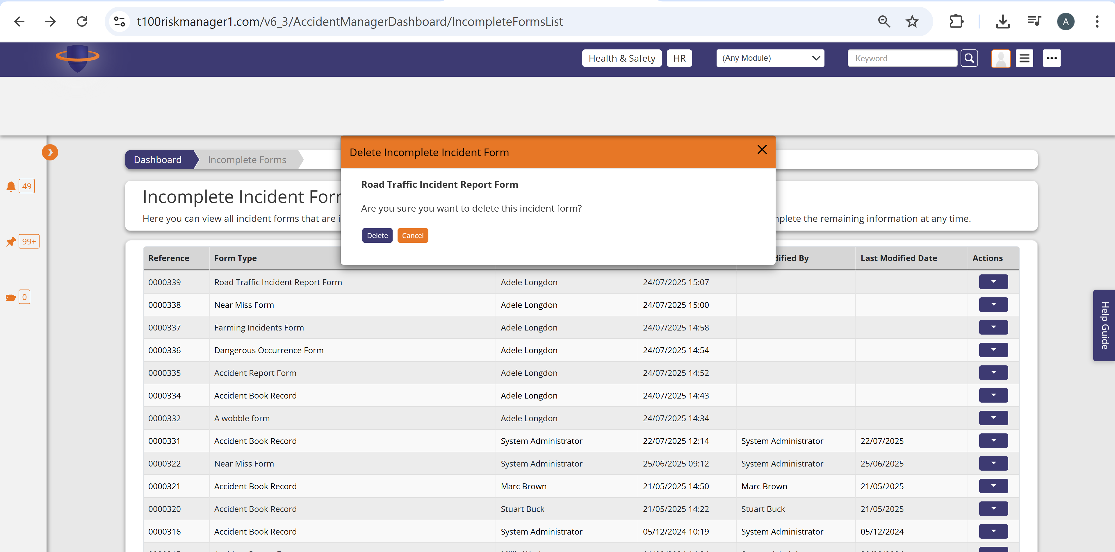

Manage Incidents –

<https://t100riskmanager1.com/v6_3/AccidentCase/ManageCasesList>

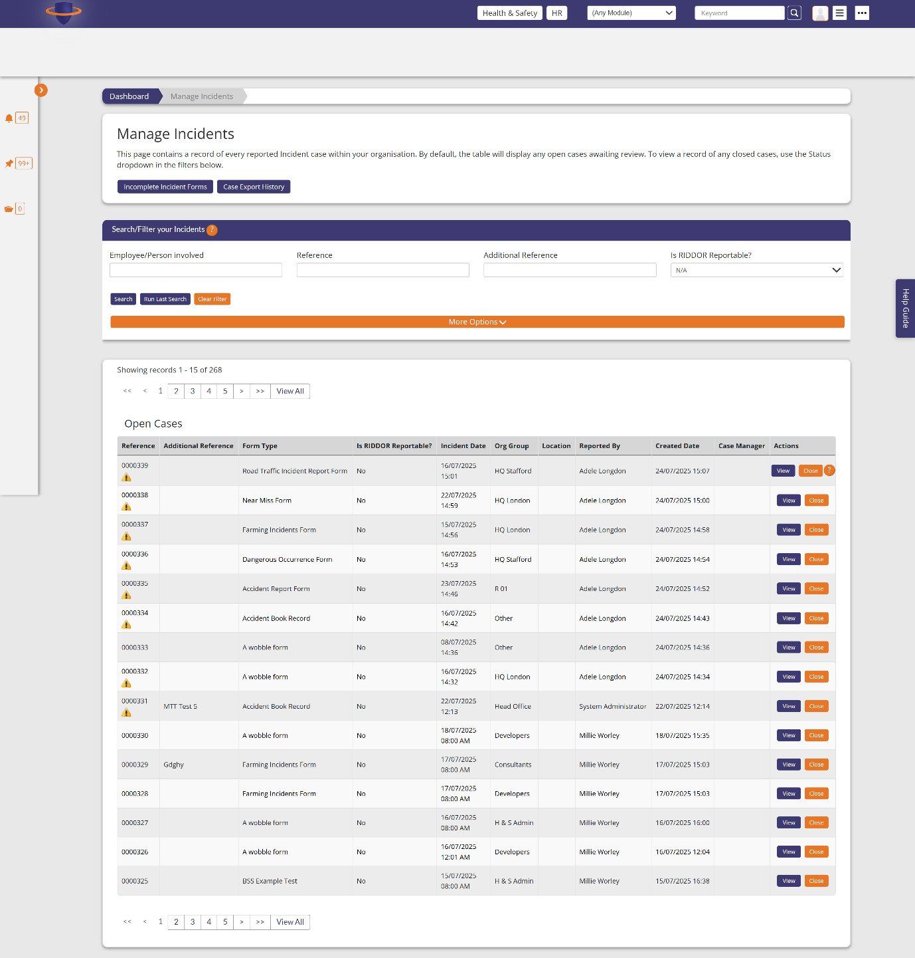

View Incident Case

<https://t100riskmanager1.com/v6_3/AccidentCase/CaseDetails?accidentCaseID=75687>

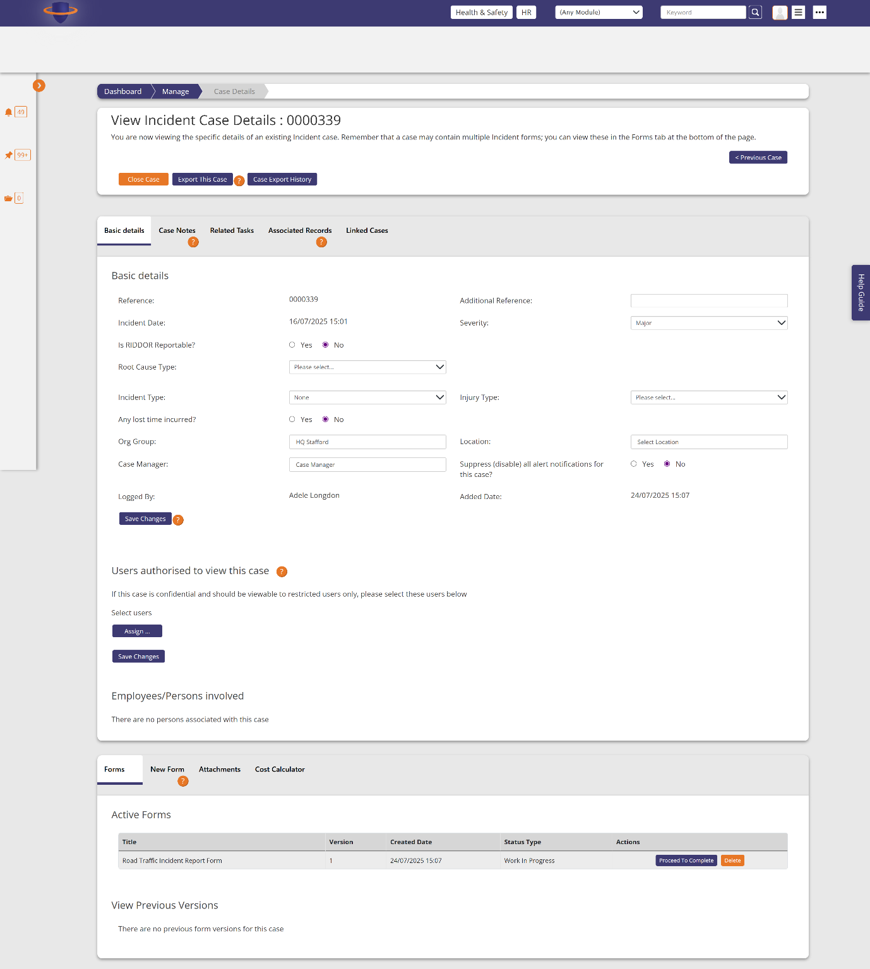

Assign users modal from page above

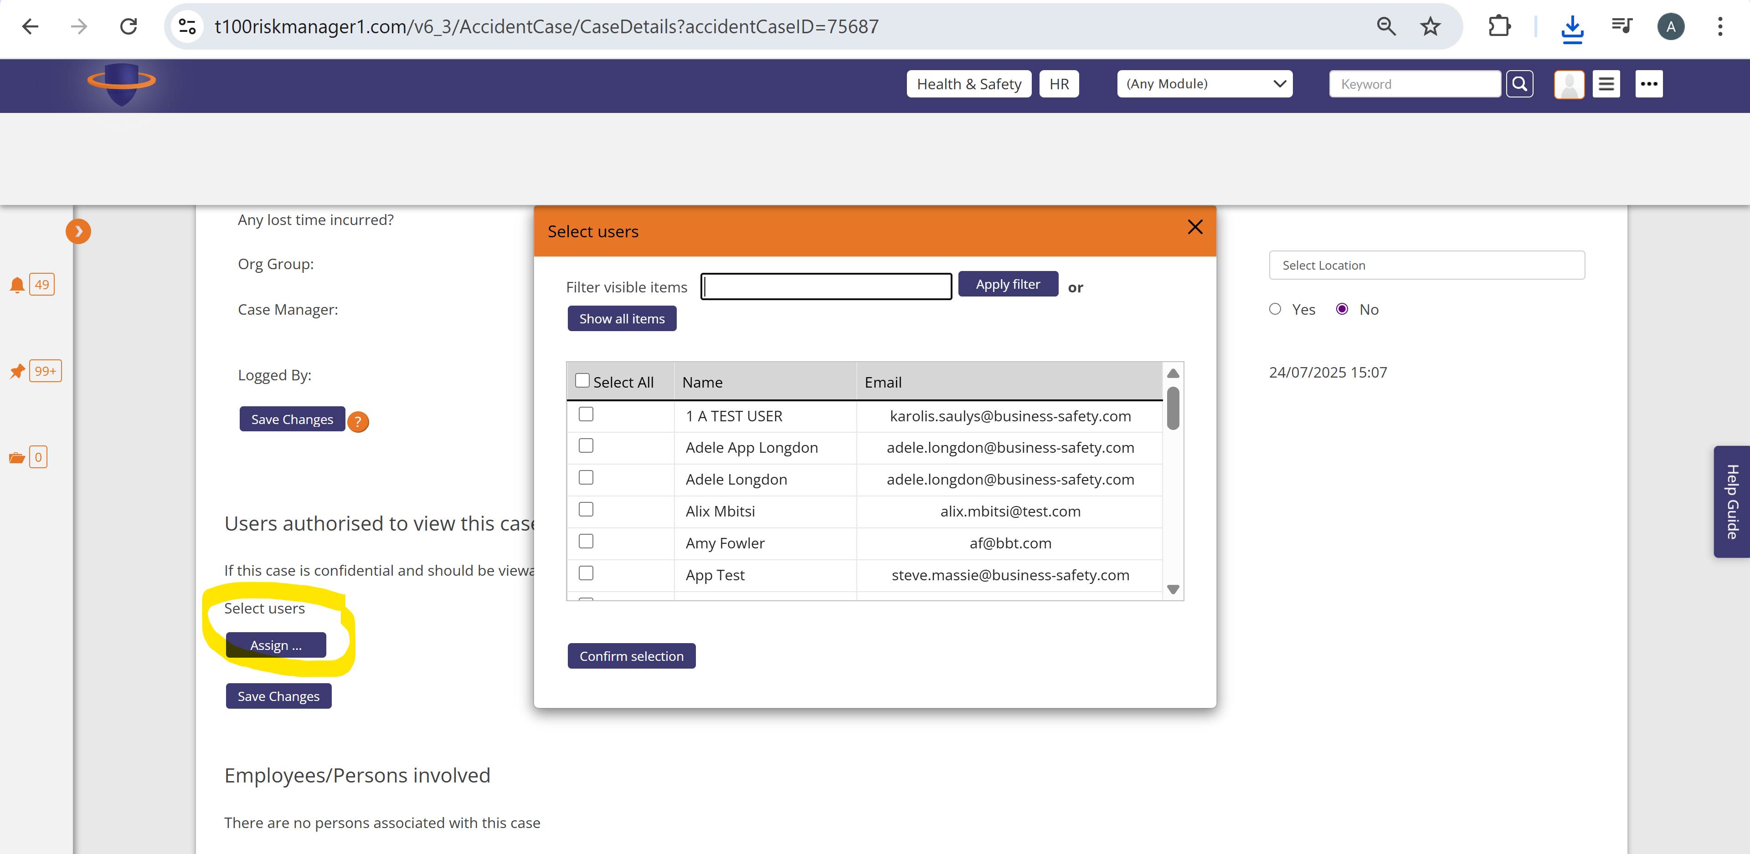

Case notes tab on same Case details page

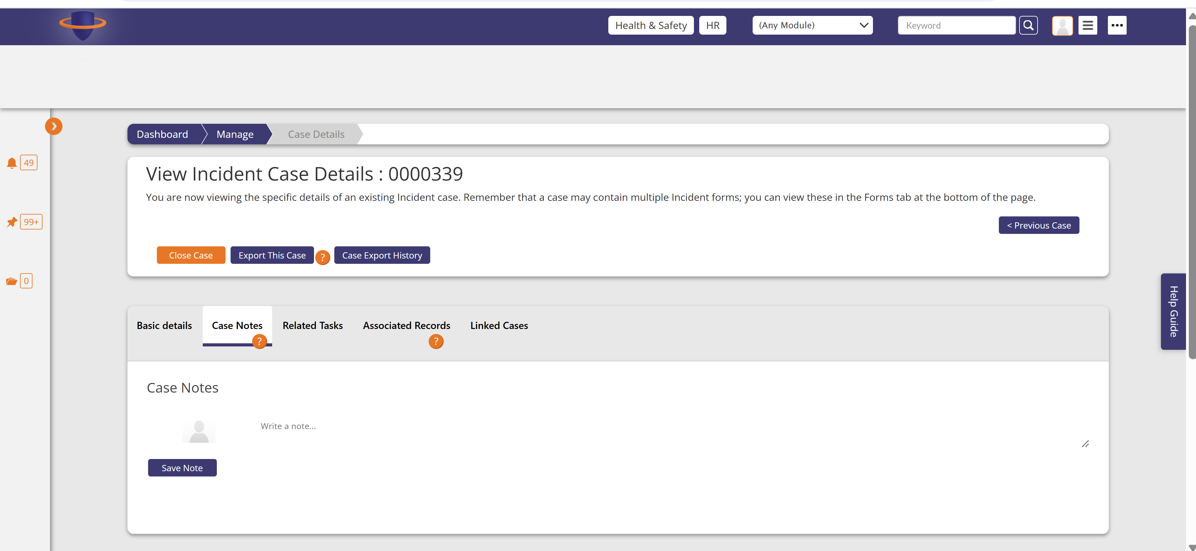

Related tasks tab on same Case details page

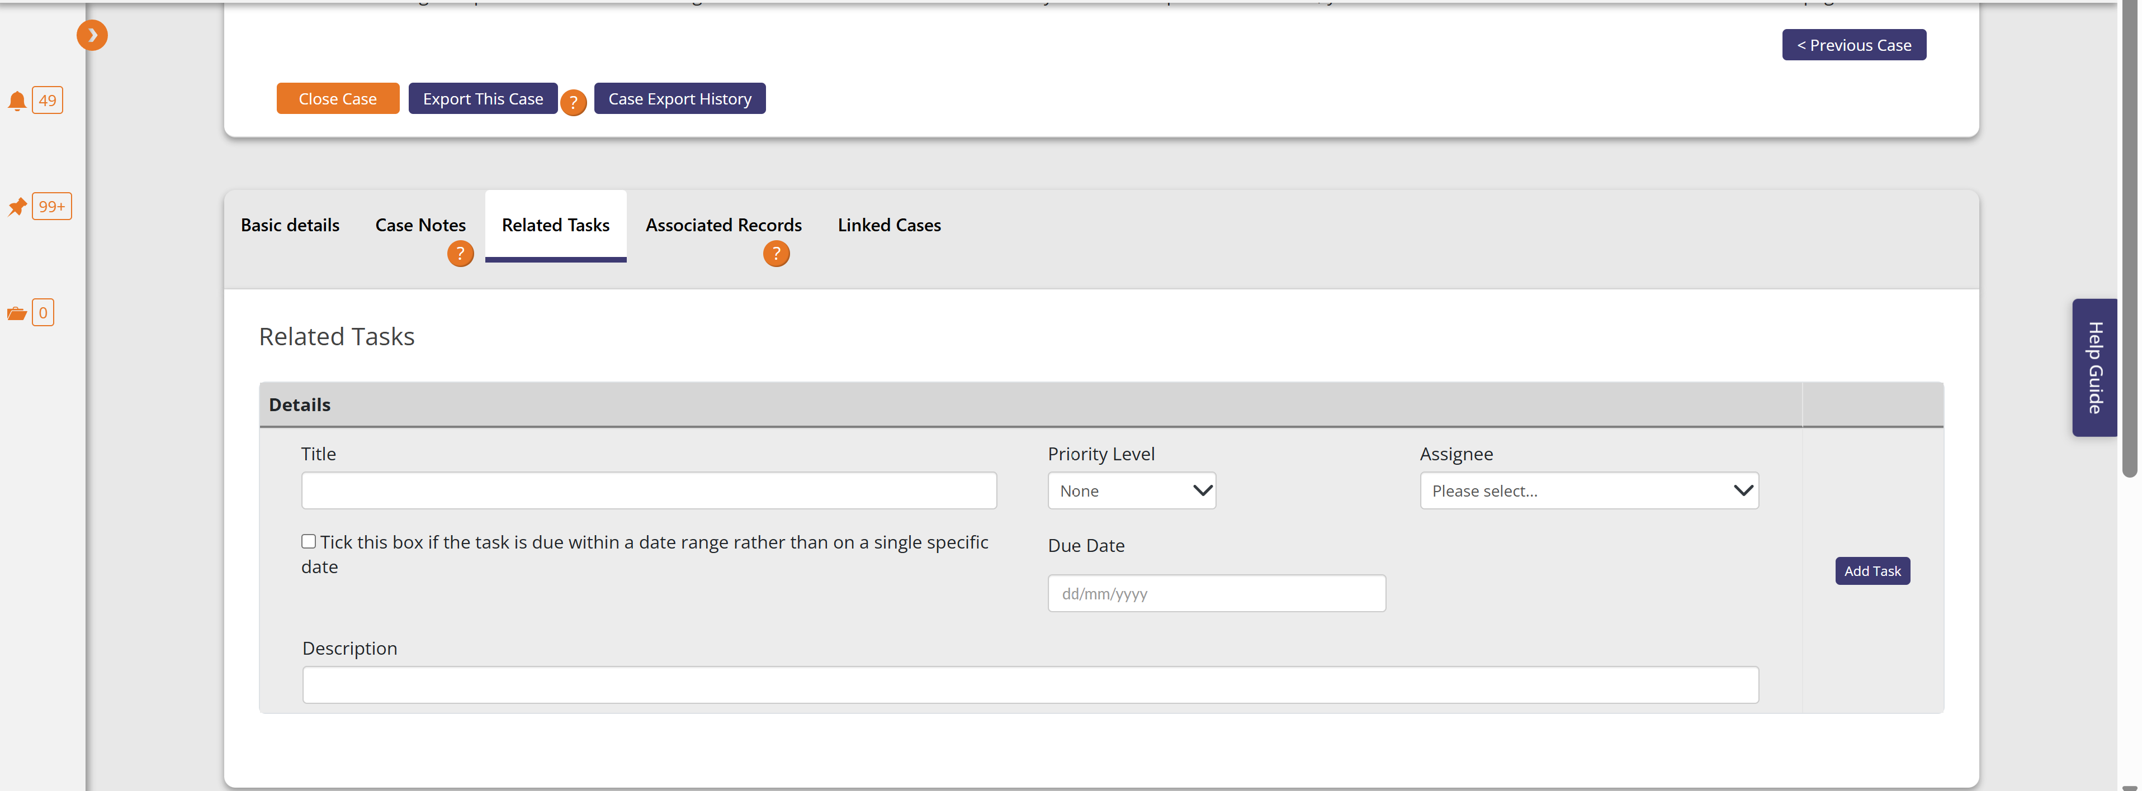

Associated records tab on same case details page

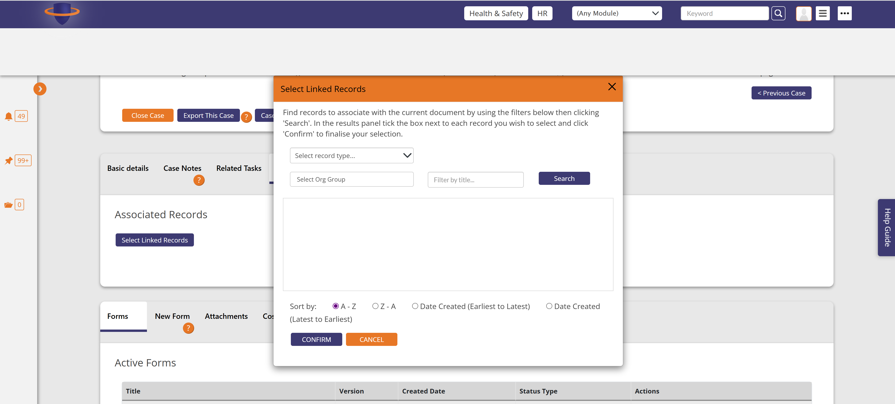

Linked cases tab on same case details page

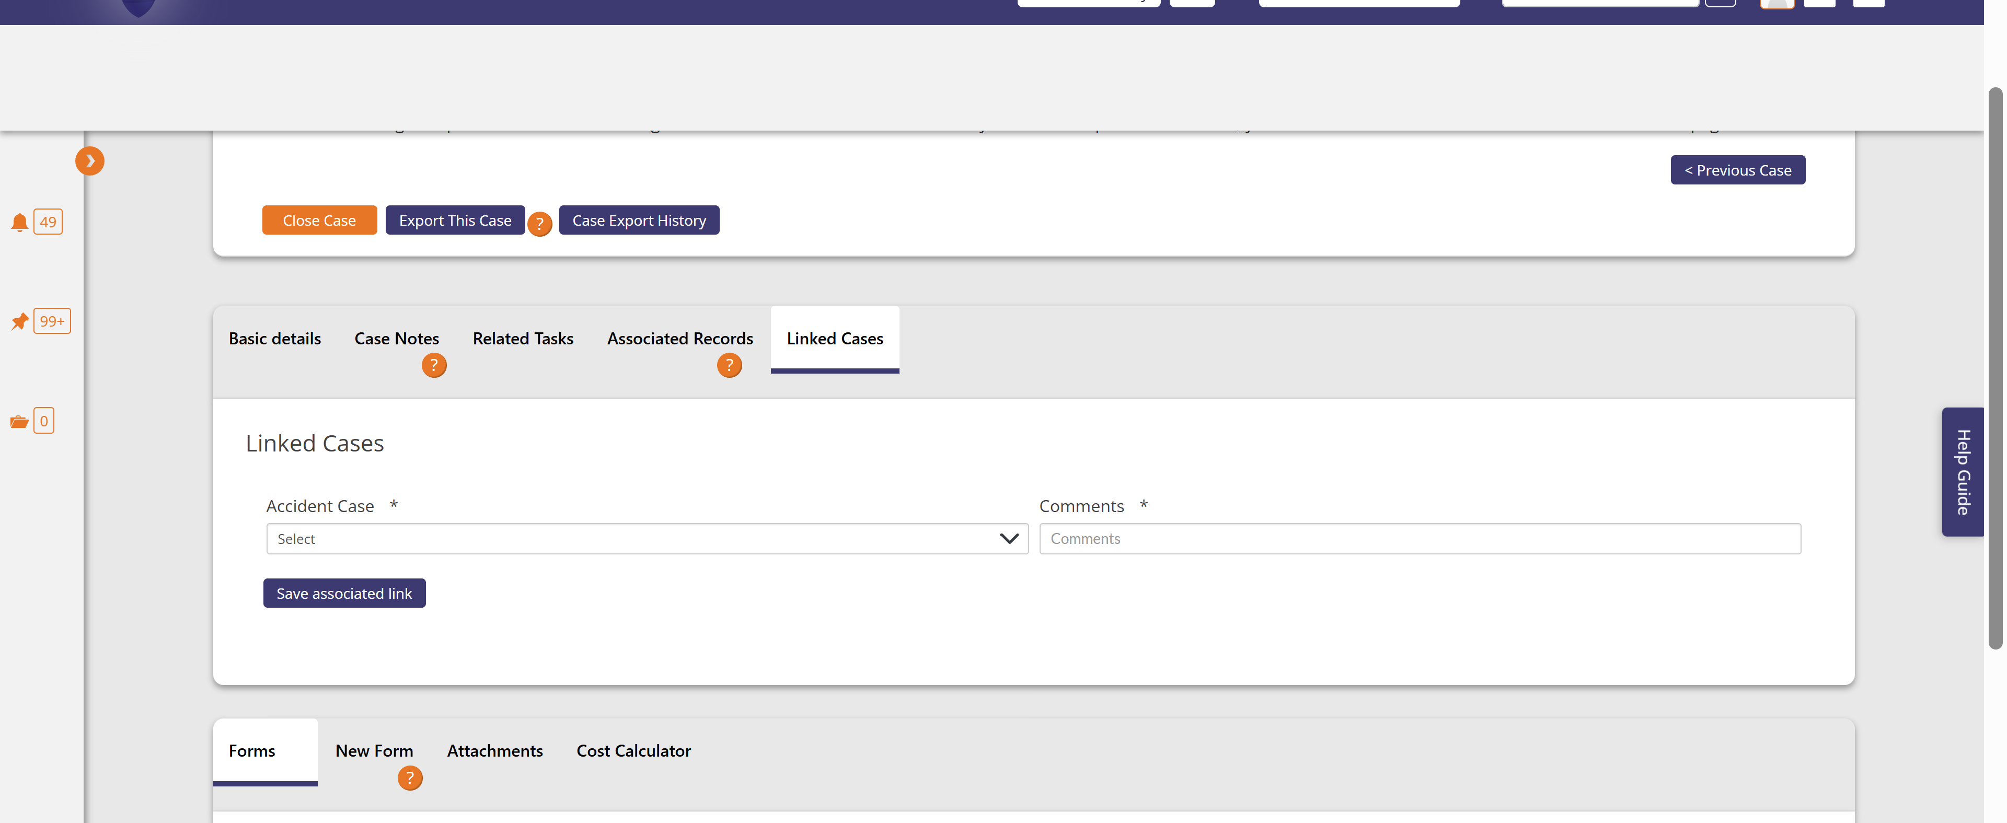

New form tab on the same case details page

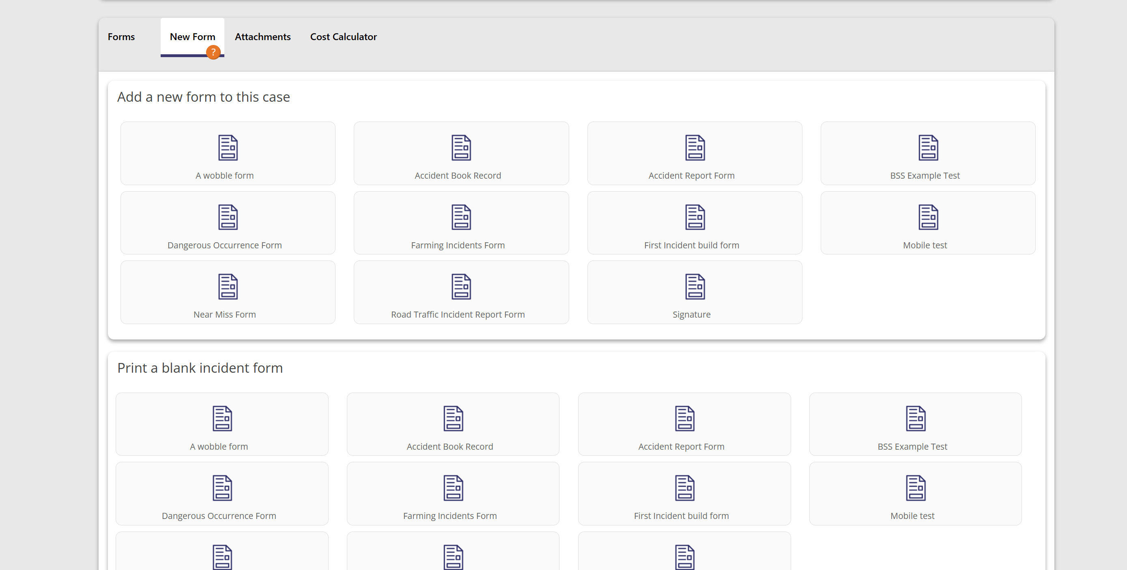

Attachments tab and modal in same case details page

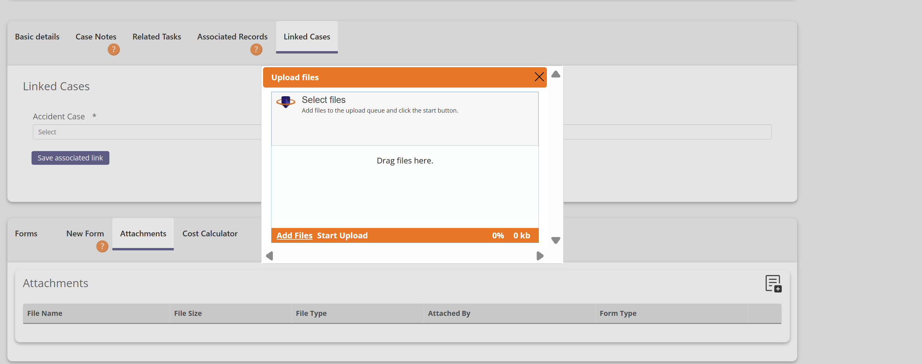

Cost calculator tab in the same case details page

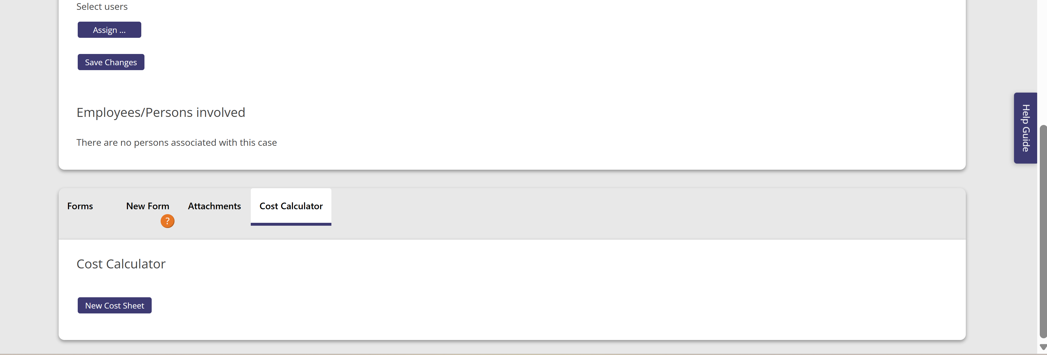

This button then loads this screen

Cost Calculator - <https://t100riskmanager1.com/v6_3/AccidentCase/CreateCostSheet?accidentCaseID=75687>

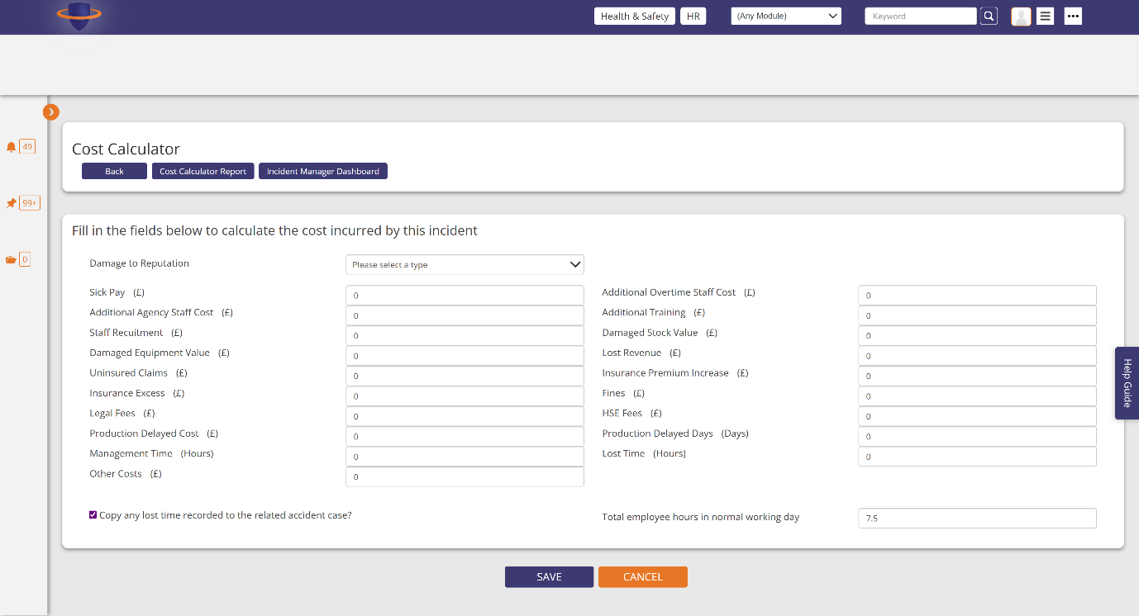

Closing a accident case modal

https://t100riskmanager1.com/v6_3/AccidentCase/ManageCasesList

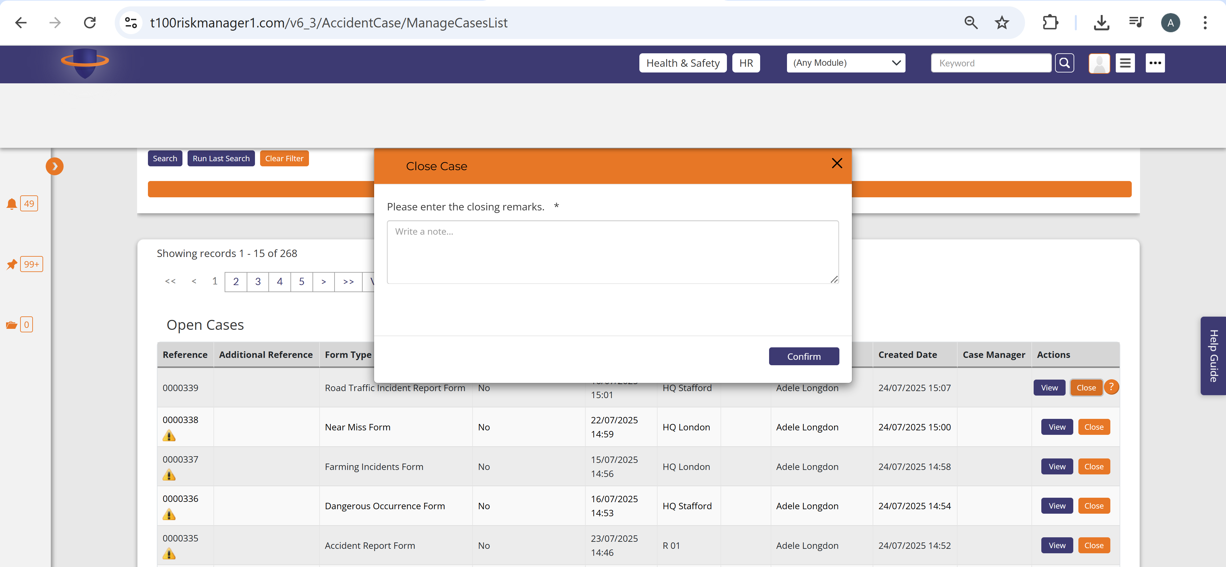

RIDDOR Reported Incidents

<https://t100riskmanager1.com/v6_3/RIDDORSubmission>

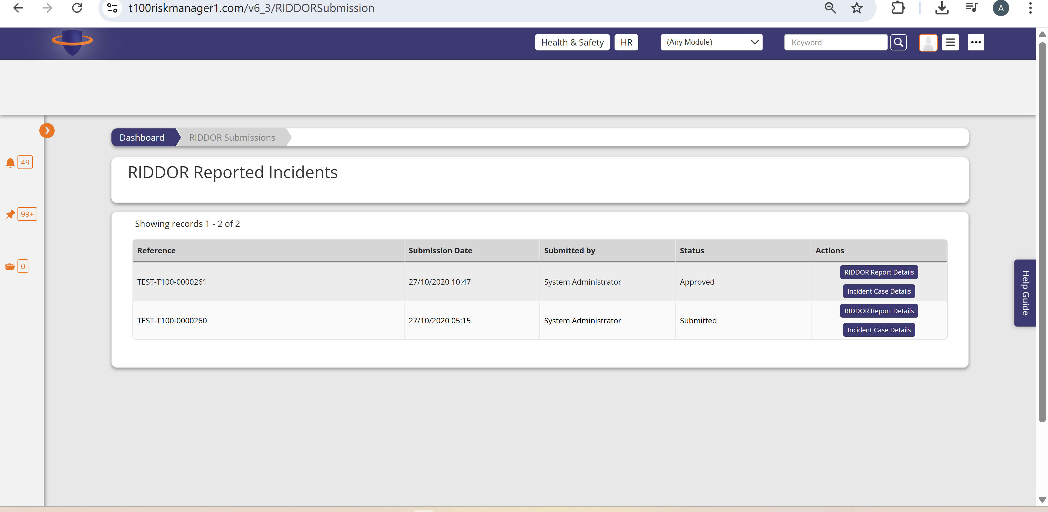

RIDDOR Reported Incident Details

<https://t100riskmanager1.com/v6_3/RIDDORSubmission/SubmissionDetails?riddorSubmissionID=4>

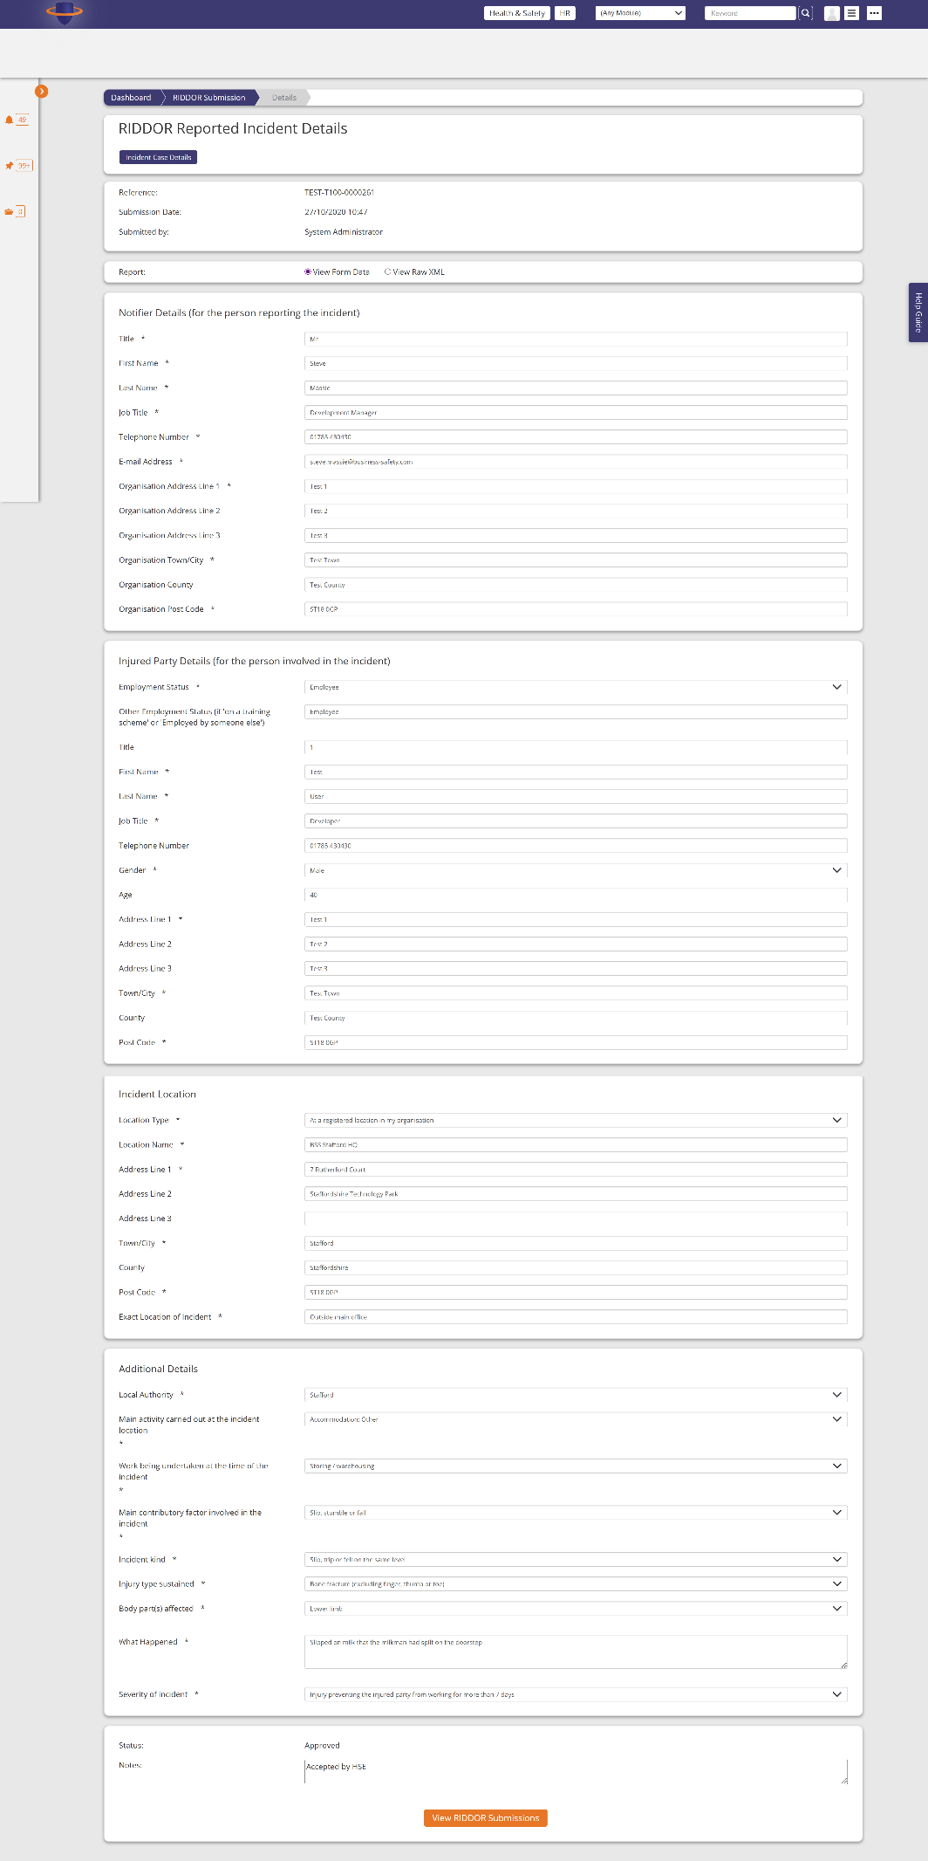

The accident case details for a riddor

<https://t100riskmanager1.com/v6_3/AccidentCase/CaseDetails?accidentCaseID=33724>

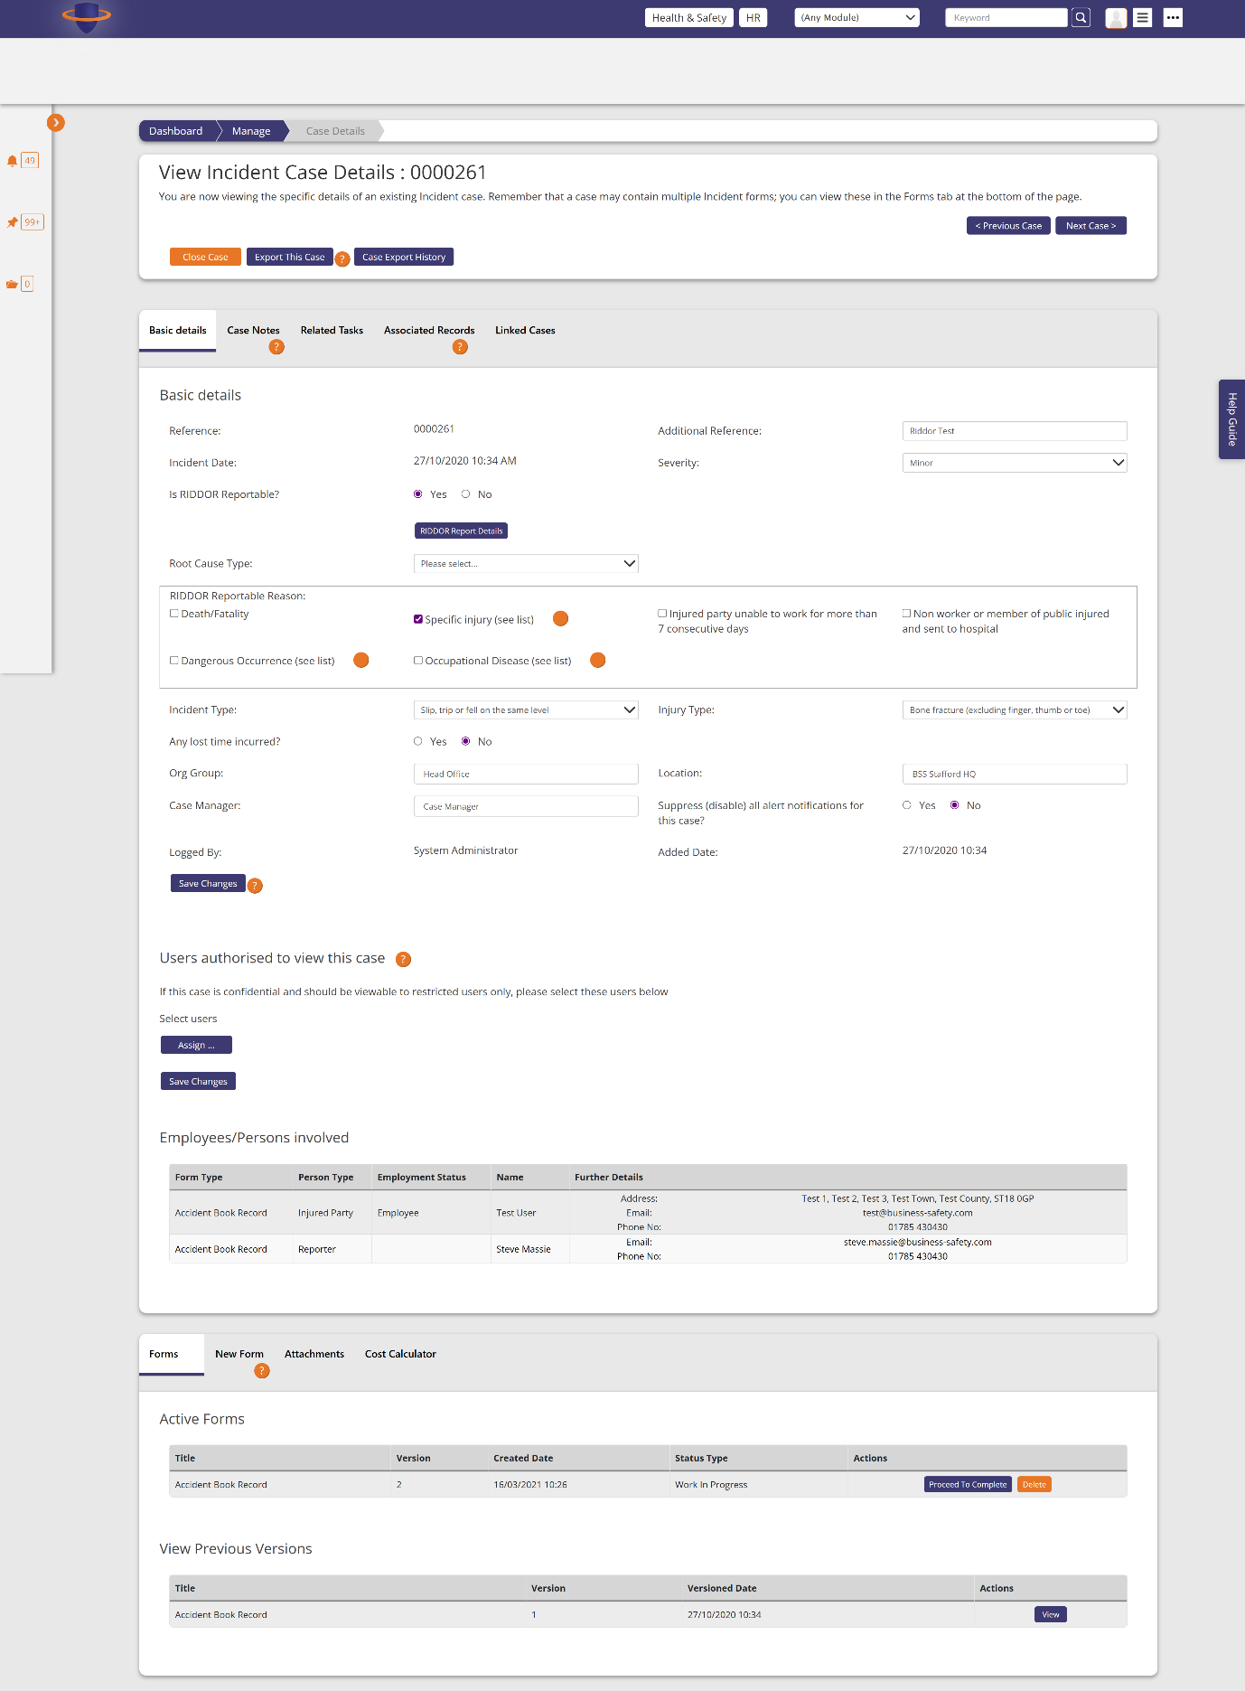

Accident form builder - <https://t100riskmanager1.com/v6_3/AccidentFormBuilder>

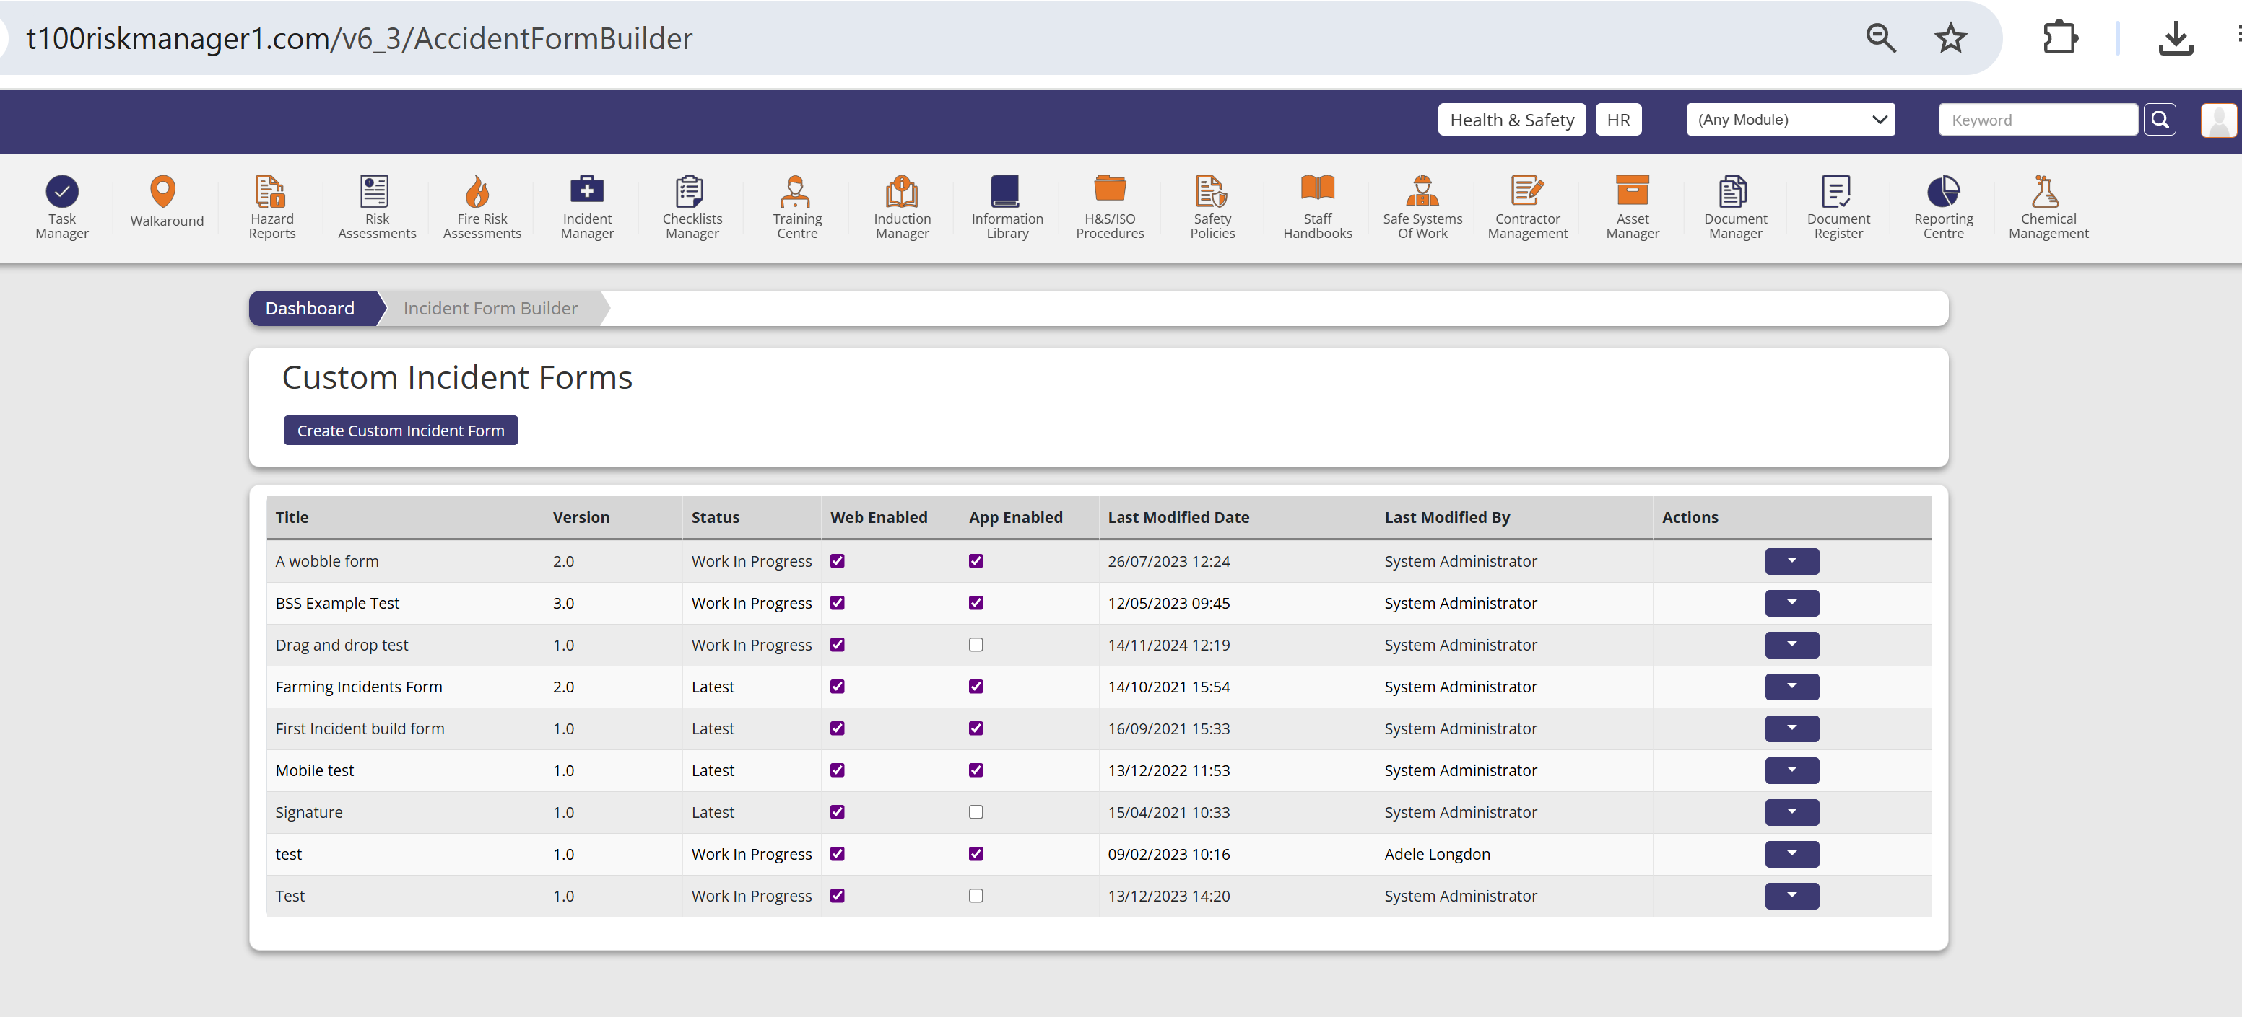

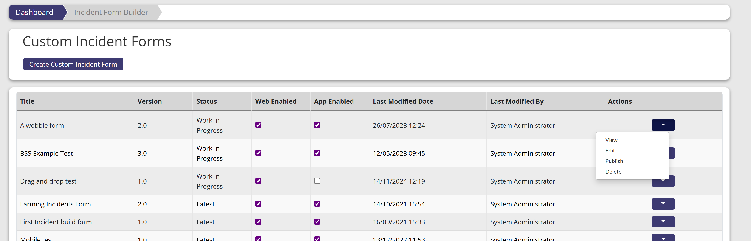

View Custom Incident Form - <https://t100riskmanager1.com/v6_3/AccidentFormBuilder/View?userAreaAccidentFormID=116>

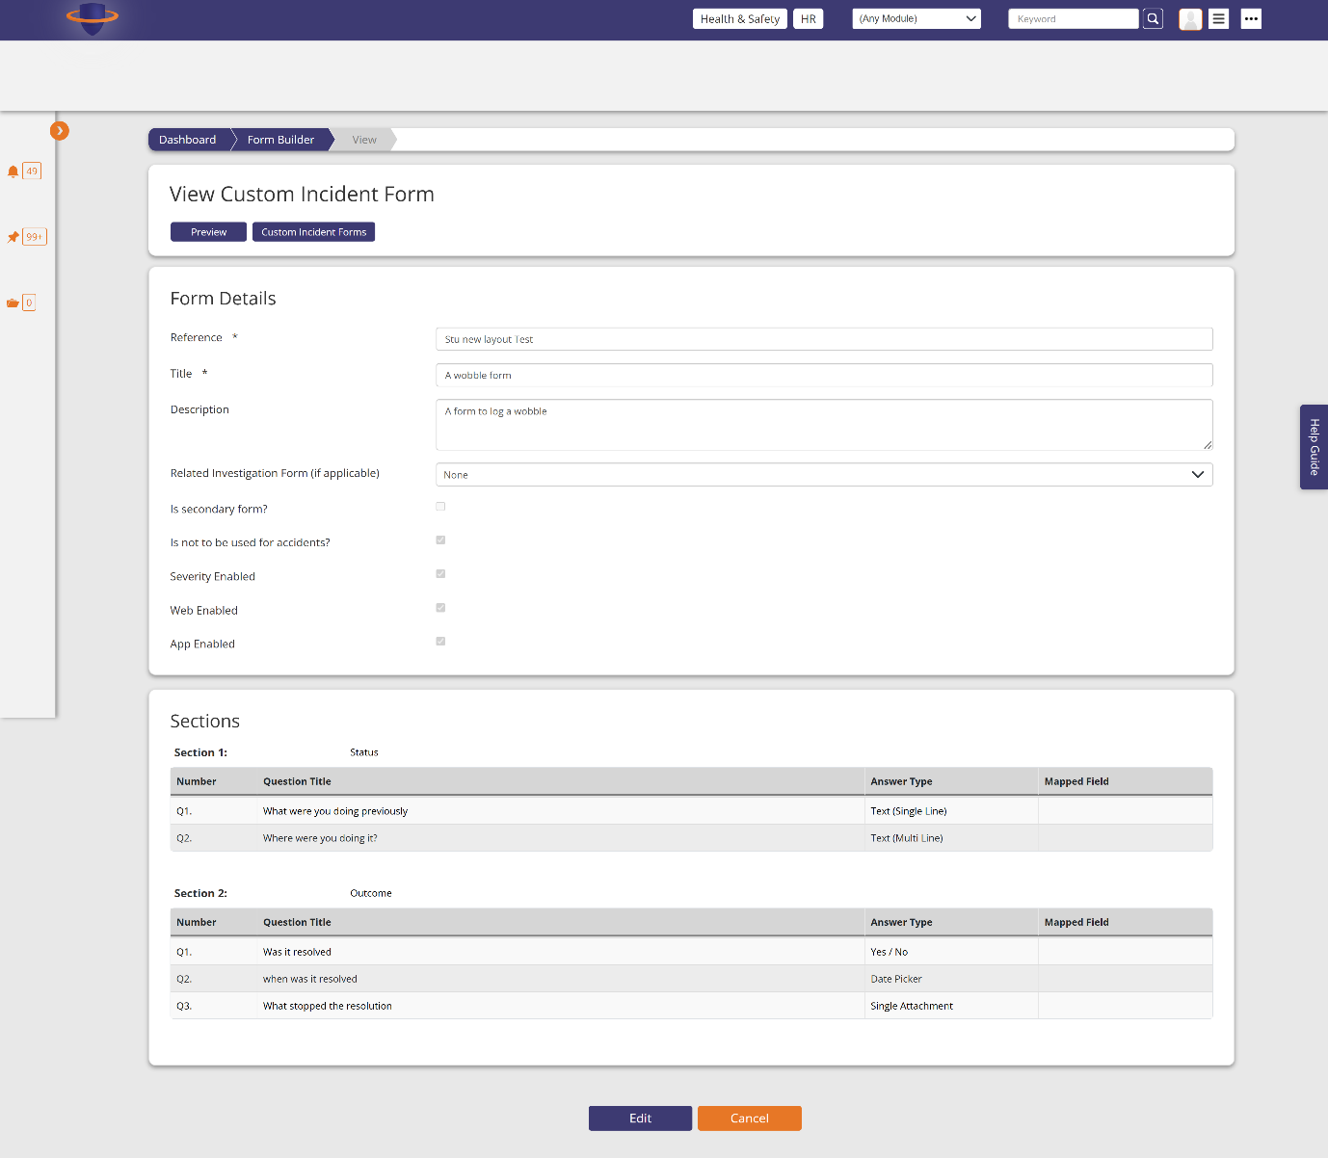

Edit Custom Incident Form

<https://t100riskmanager1.com/v6_3/AccidentFormBuilder/Edit?userAreaAccidentFormID=116>

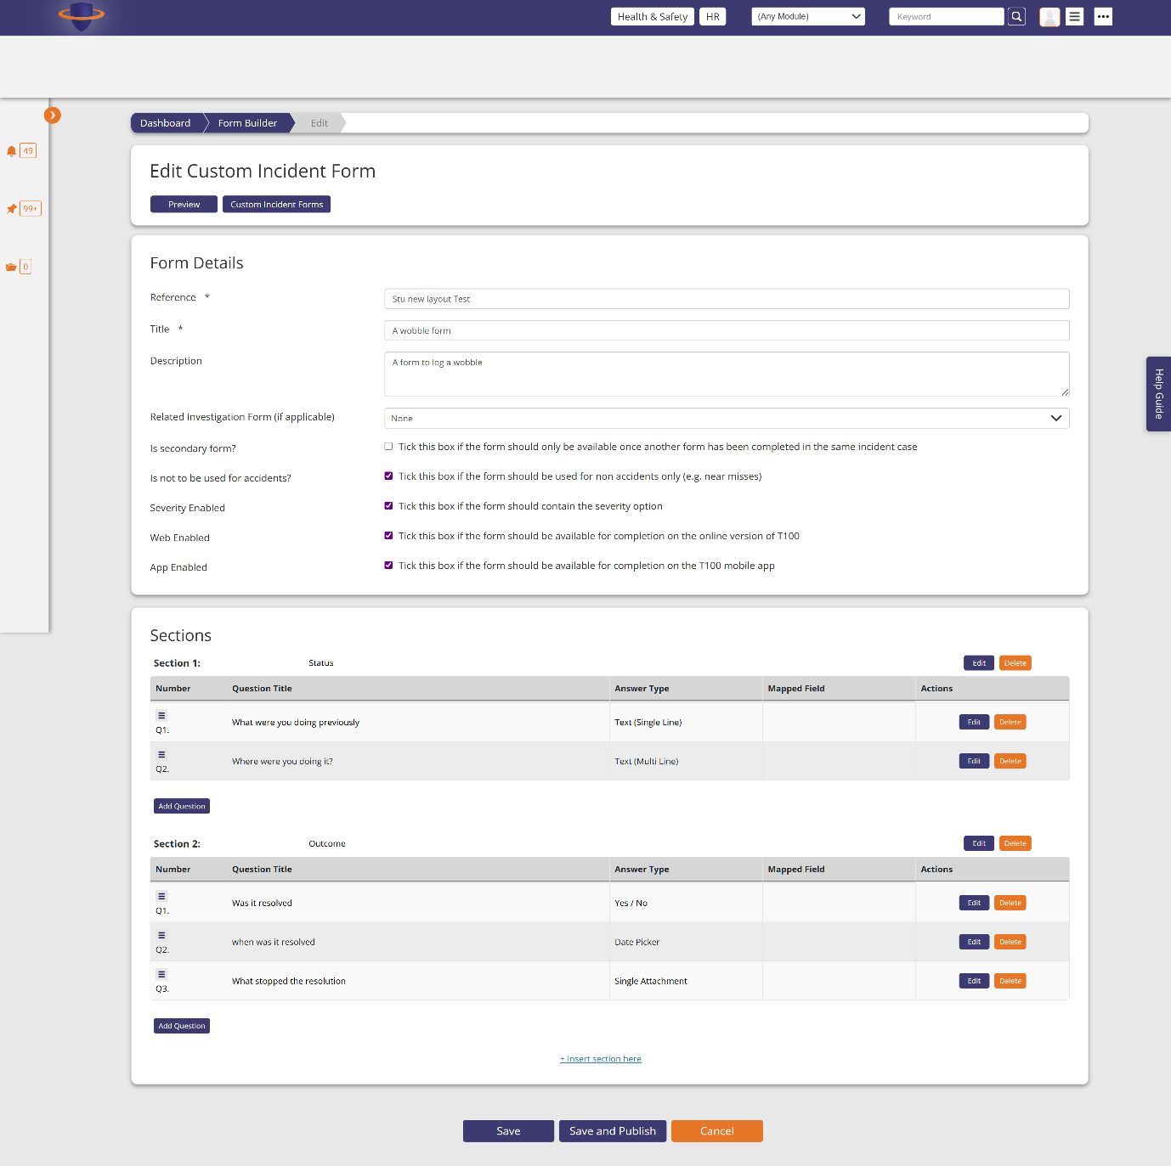

An are you sure modal to publish a custom form

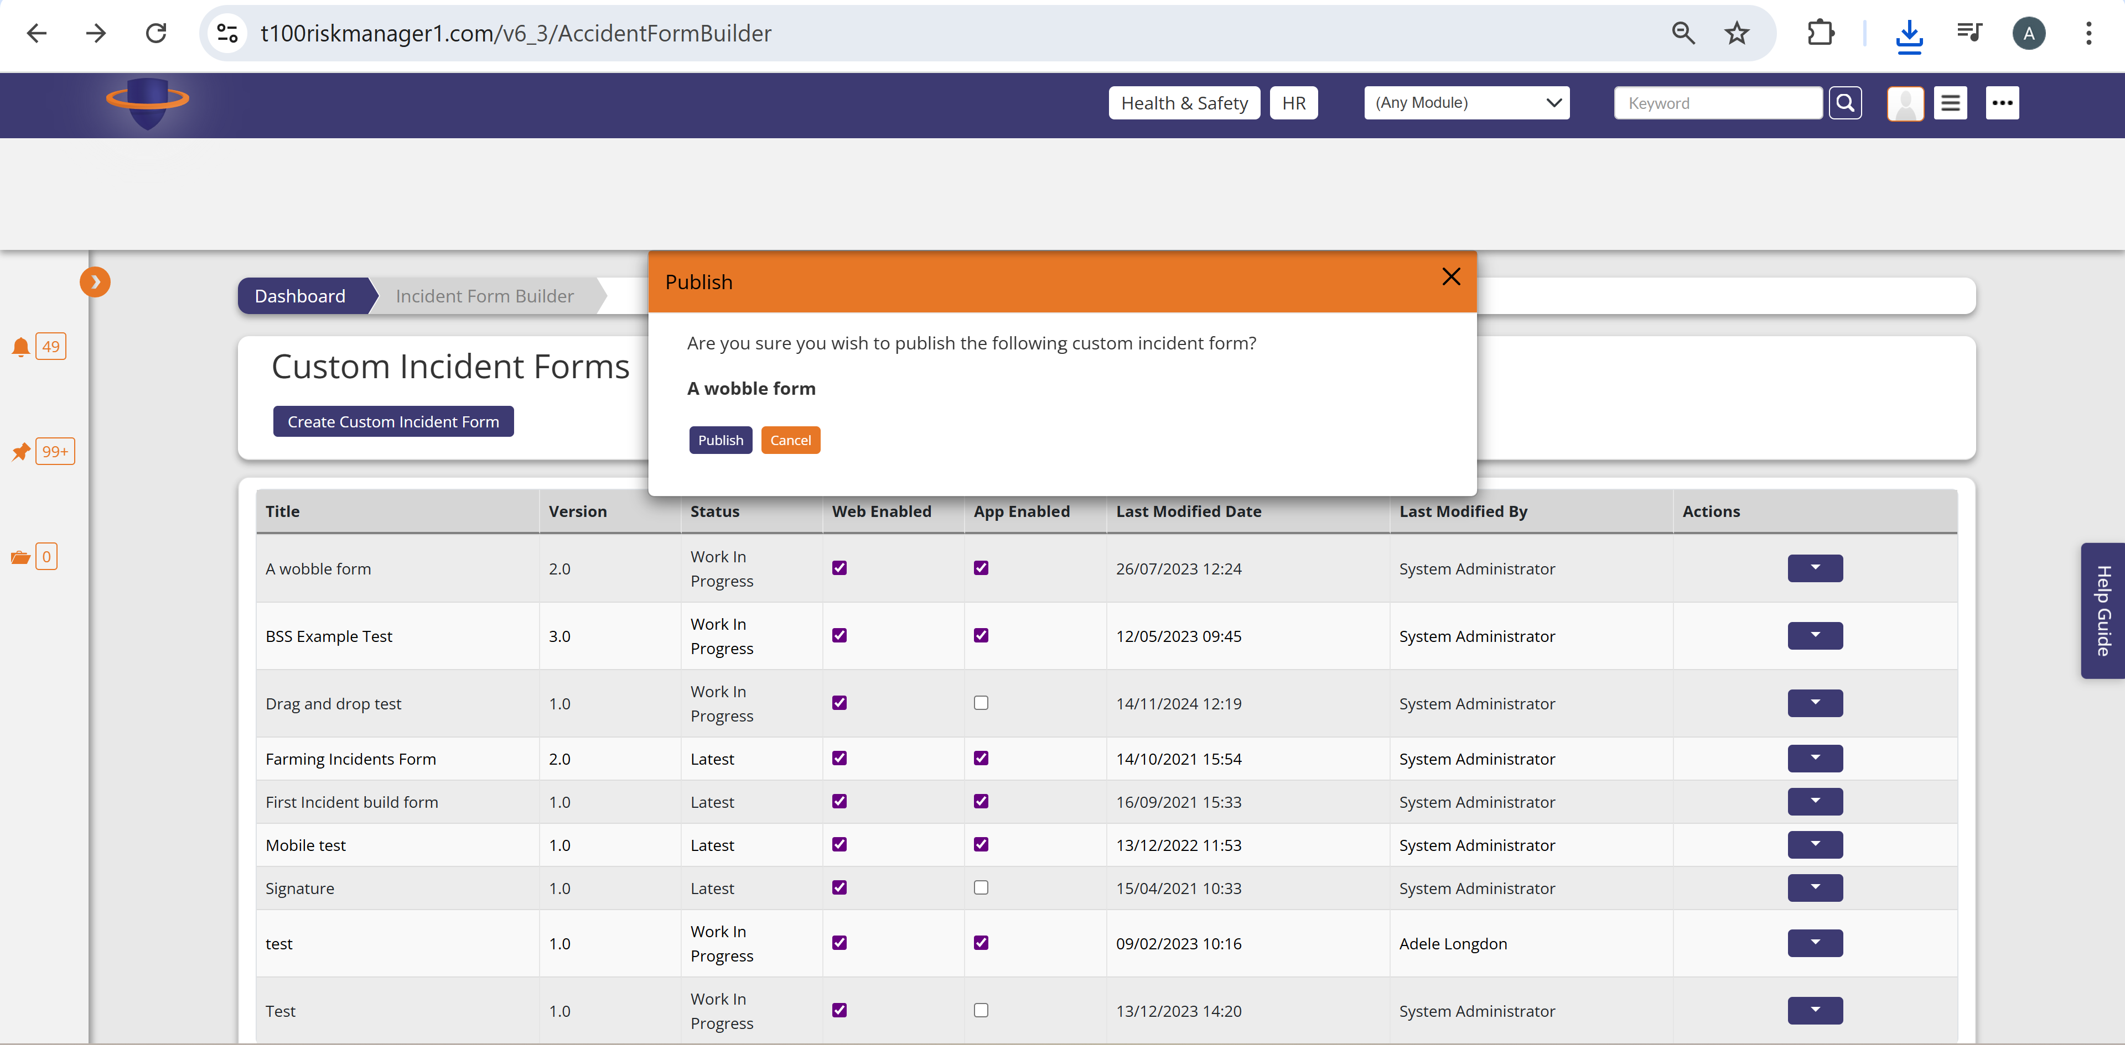

Delete Custom Incident Form

<https://t100riskmanager1.com/v6_3/AccidentFormBuilder/Delete?userAreaAccidentFormID=116>

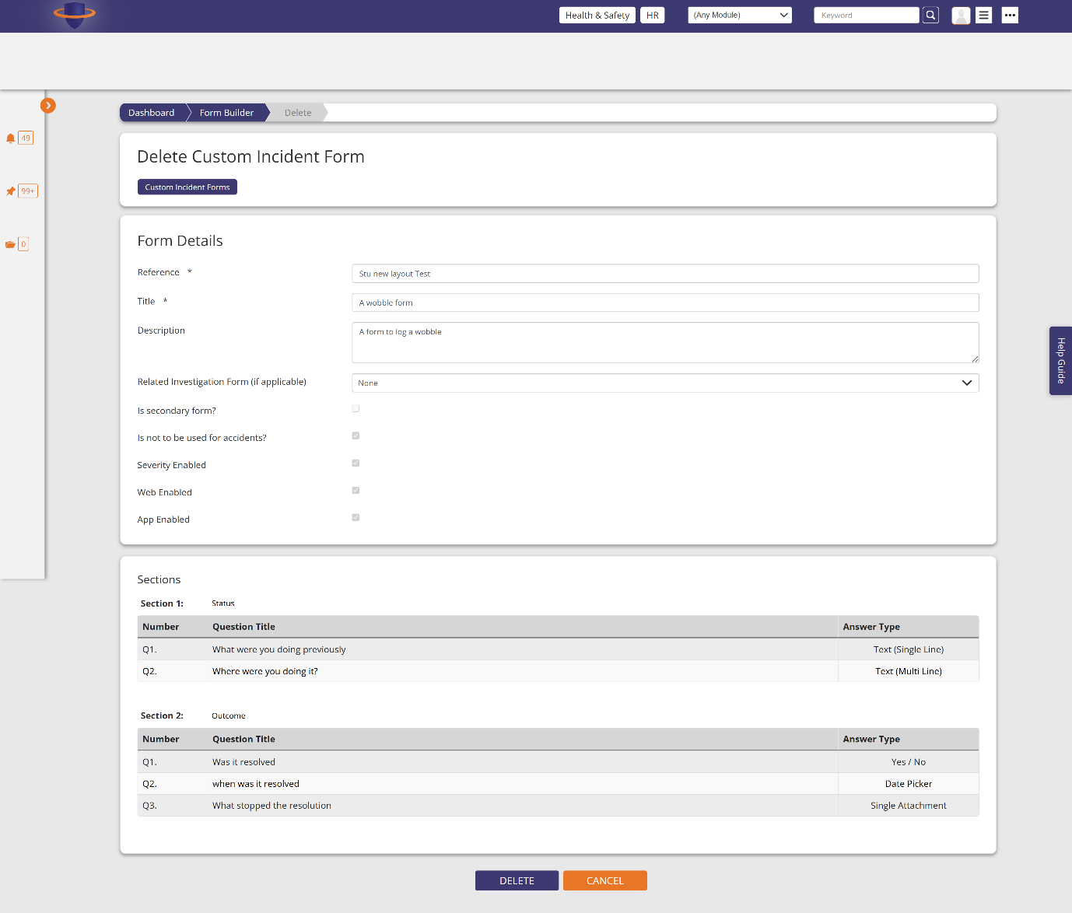

Create a custom form

<https://t100riskmanager1.com/v6_3/AccidentFormBuilder/Create>

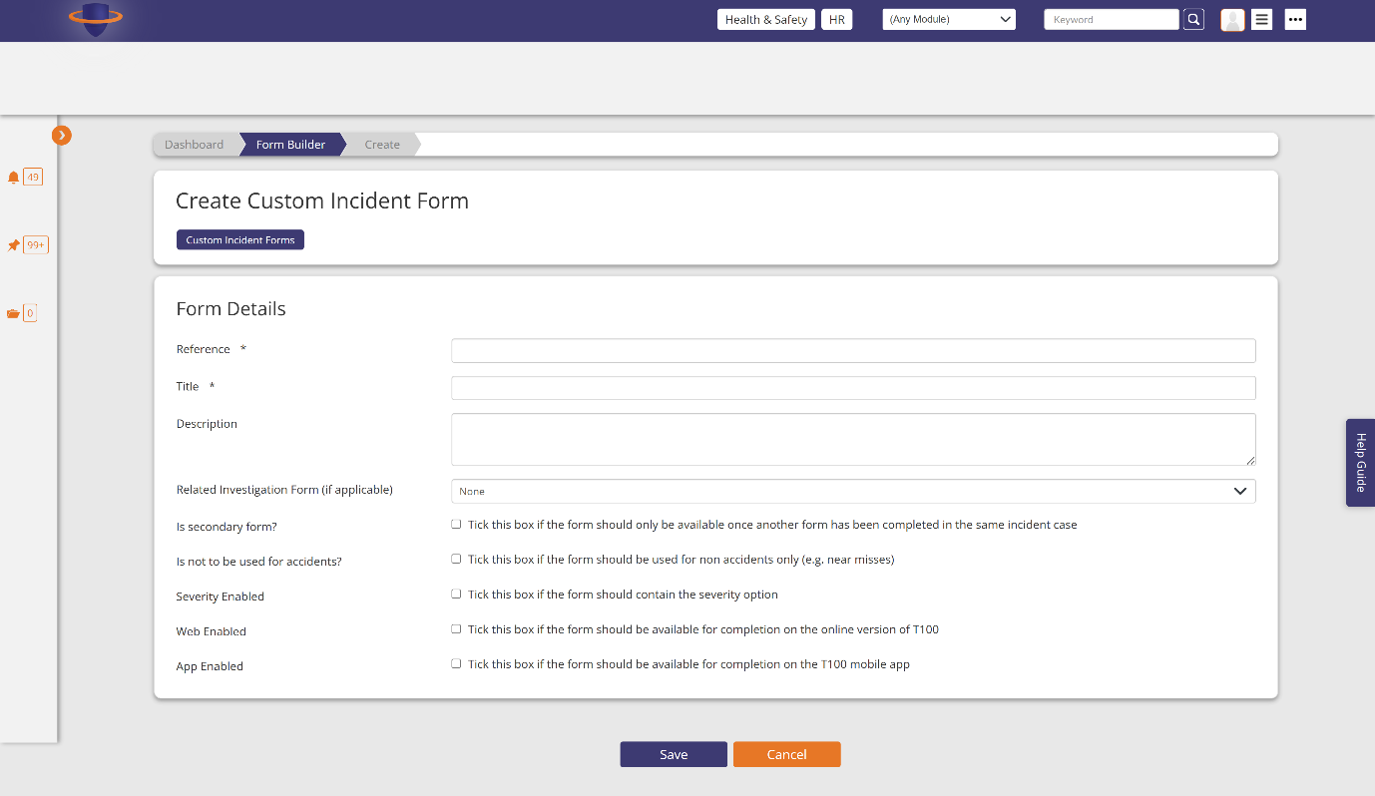

Same create custom page – add a section

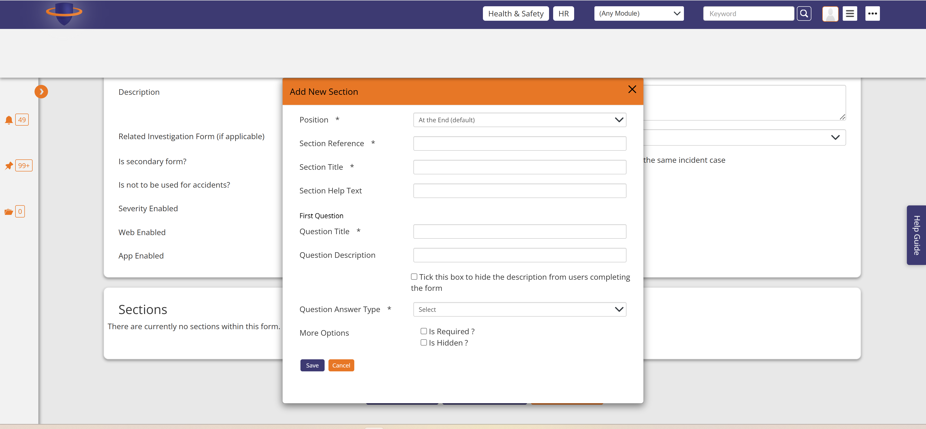

Same create custom page with the section added to the form

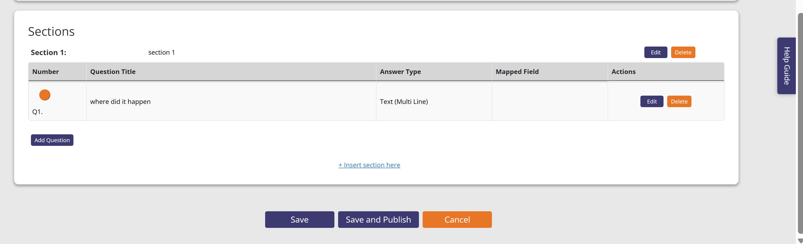

Reports page – summary report

<https://t100riskmanager1.com/v6_3/AccidentManagerReport/Summary>

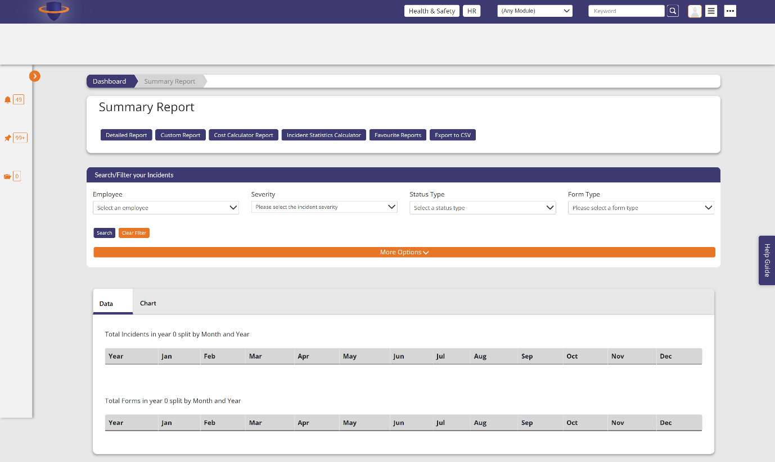

Reports page – Detailed report <https://t100riskmanager1.com/v6_3/AccidentManagerReport/Detailed>

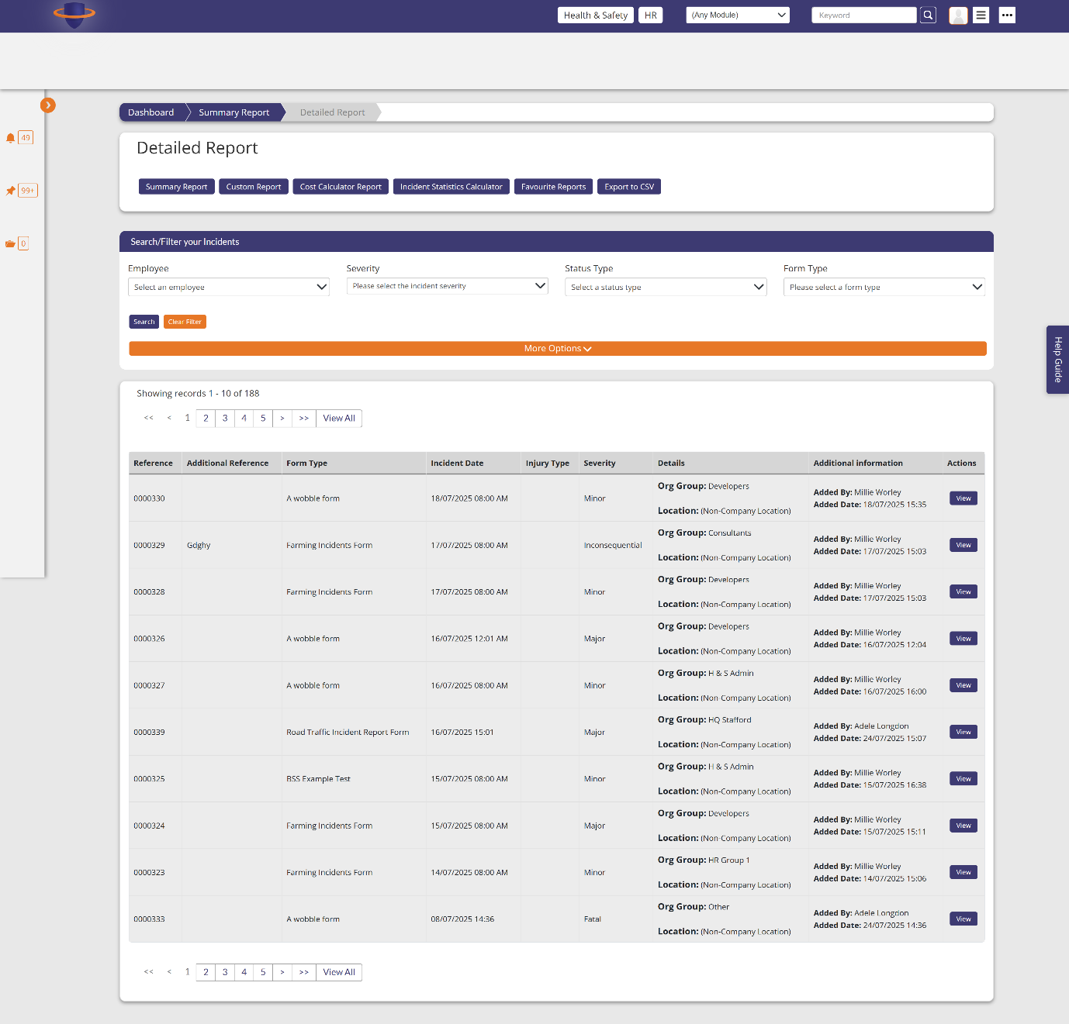

Reports – custom report

<https://t100riskmanager1.com/v6_3/AccidentManagerReport/Custom>

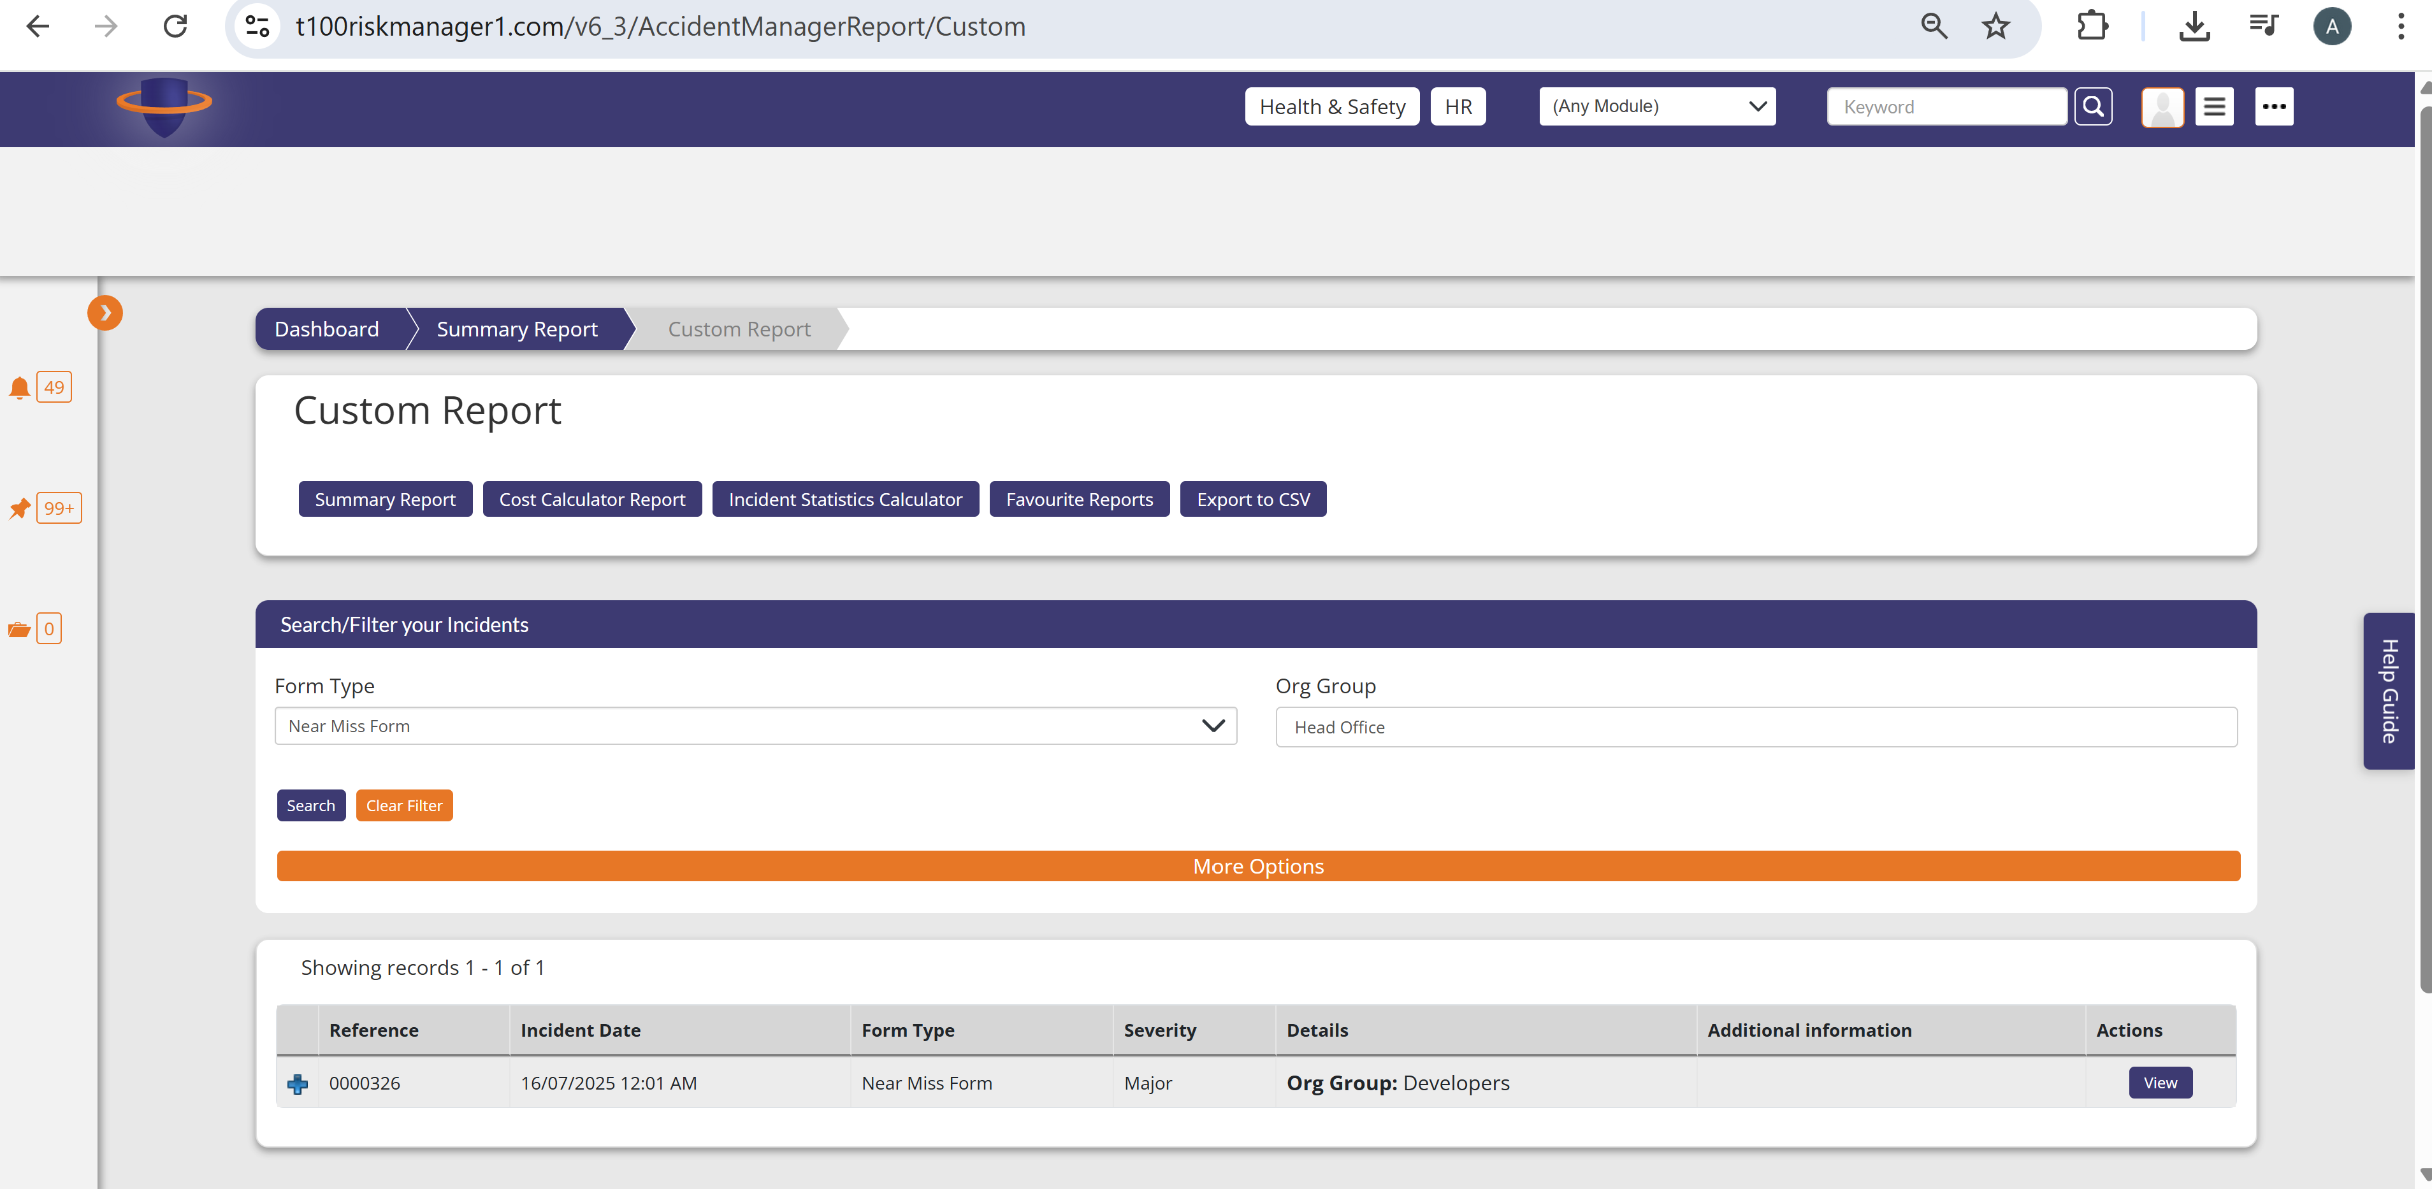

Incident Statistics Calculator

<https://t100riskmanager1.com/v6_3/AccidentManagerReport/IncidentStatisticsCalculatorReport>

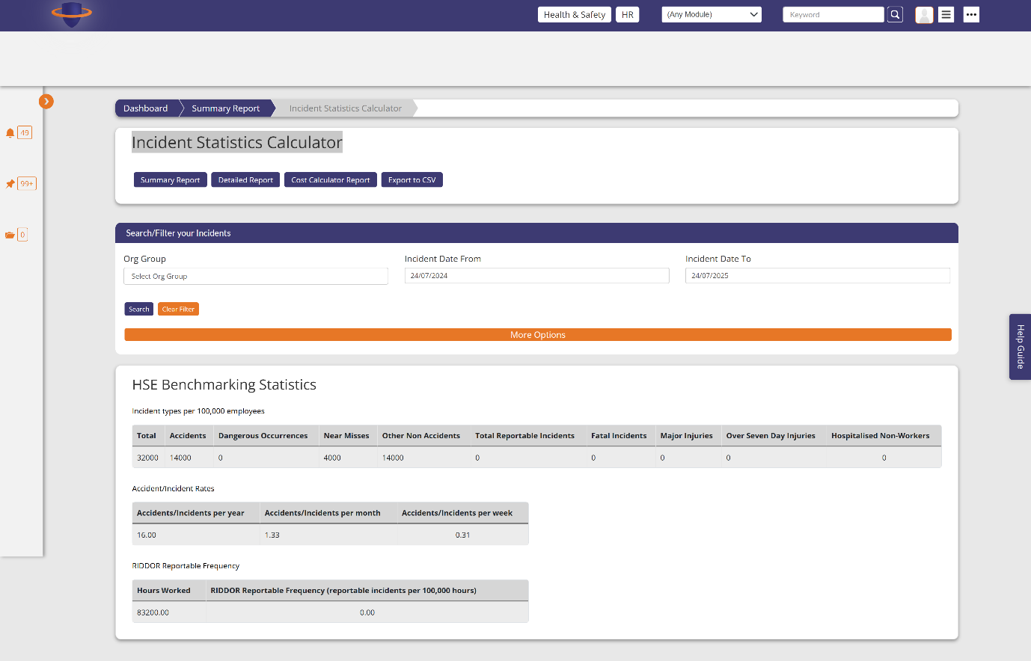

Save a report to favourites modal

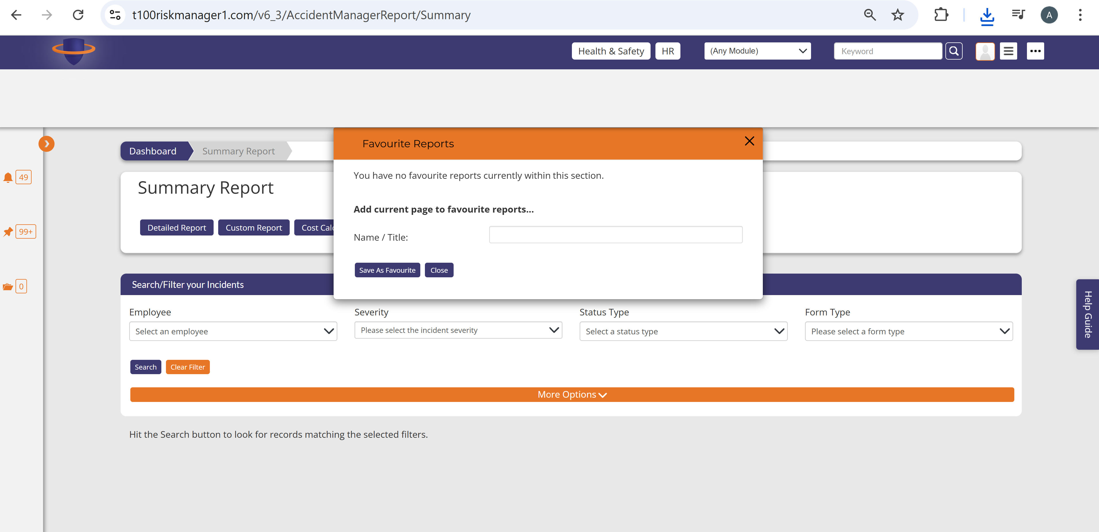

Export to csv modal

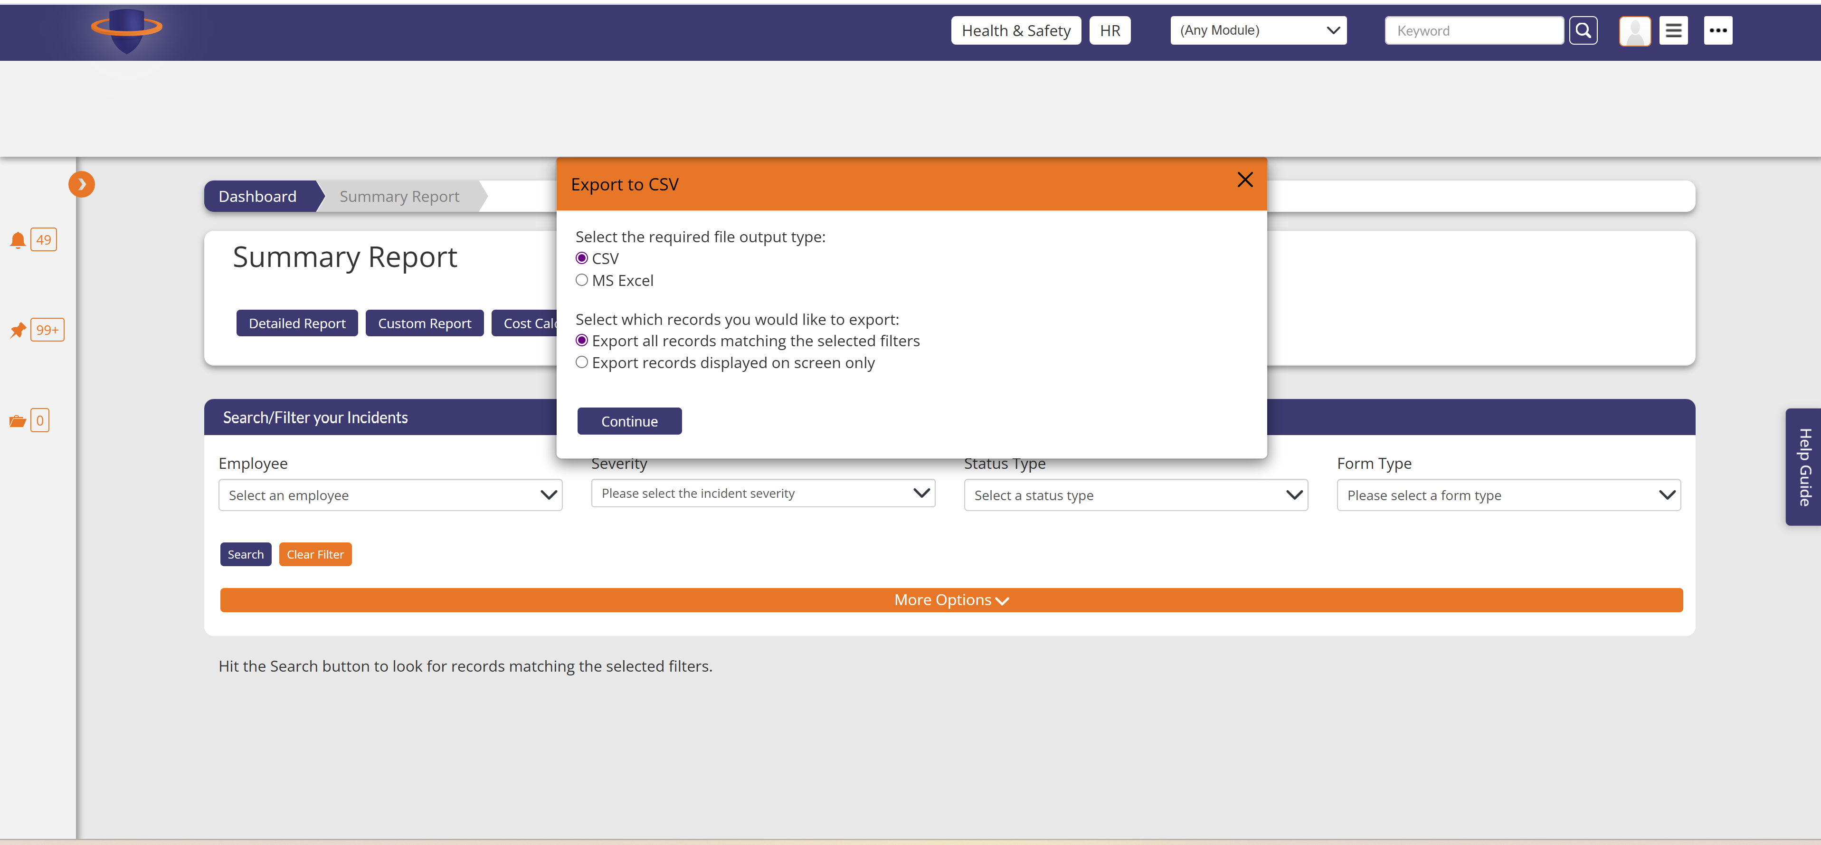

Incident Manager Dashboard

<https://t100riskmanager1.com/v6_3/AccidentManagerDashboard>

